VectorGraphNet — FloorplanCAD Semantic Segmentation
Source notebook: Delaunay VectorGraphNET v4.ipynb
Heterogeneous GAT over SVG paths with a DeepSVG-style command encoder, three edge types (k-NN, Voronoi, weld), and three hierarchical heads (coarse / mid / fine). Trained with focal loss on the long-tailed fine head.
Run order
- Install — pip installs (run once)
- Setup — data, model, datasets (run once per session)
- Train — skip if loading a pretrained checkpoint
- Verify labels — render a real floor plan by ground-truth class ids
- Results — heatmaps, confusion table, B&W vs predicted vs GT, test eval
To produce images from an existing checkpoint without training, set CHECKPOINT_TO_LOAD at the top of the Results cell and run only Install → Setup → Verify labels → Results.

1. Install dependencies
Colab-friendly: PyG ships prebuilt wheels matching the active torch version.
Code | 20 lines
# ============================================================
# 1. Install dependencies
# ============================================================
import subprocess, sys

PACKAGES = [
"torch_geometric",
"svgpathtools", "lxml", "gdown",
"scikit-learn", "tqdm",
]

for pkg in PACKAGES:
print(f" installing {pkg} ...", flush=True)
subprocess.run(
[sys.executable, "-m", "pip", "install", "-q", pkg],
check=True,
)

print("\nAll dependencies installed.")

Output
installing torch_geometric ...
installing svgpathtools ...
installing lxml ...
installing gdown ...
installing scikit-learn ...
installing tqdm ...

All dependencies installed.

2. Setup
Imports, Drive mount, dataset construction, label hierarchy, SVG parsing, graph builder, model definition. Run once per session.
Code | 767 lines
# ============================================================
# 2. Setup: KNN + Weld + Delaunay Hypergraph
# ============================================================
# Three message-passing channels:
# KNN — pairwise GAT, k=8 nearest centroids
# Weld — pairwise GAT, endpoint co-location + style match
# Delaunay — HypergraphConv over Delaunay triangles
#
# Voronoi removed (ablation showed +2.4 wF1 — we're testing whether
# Delaunay triangles can replace AND exceed that contribution by
# capturing three-way spatial groupings).
#
# Batching trick: triangles stored as a virtual 'hedge' node type
# with edges ('path','in_triangle','hedge'). PyG increments both
# path and hedge indices correctly during collation. The model
# extracts this edge_index and passes it to HypergraphConv.

import os
os.environ["PYTORCH_CUDA_ALLOC_CONF"] = "expandable_segments:True"

import sys, json, math, random, time, glob, zipfile, re, types
from pathlib import Path
from collections import Counter, defaultdict
from itertools import combinations
from xml.etree import ElementTree as ET

import numpy as np
import torch
import torch.nn as nn
import torch.nn.functional as F
from torch.utils.checkpoint import checkpoint

import torch_geometric
from torch_geometric.data import Data, HeteroData, InMemoryDataset
from torch_geometric.loader import DataLoader
from torch_geometric.nn import GATv2Conv, HypergraphConv

import svgpathtools
from scipy.spatial import KDTree, Delaunay, QhullError
from sklearn.neighbors import NearestNeighbors
from sklearn.metrics import f1_score, classification_report
from tqdm.auto import tqdm

from IPython.display import HTML, display

def banner(title, char="="):
line = char * 60
print(f"\n{line}\n {title}\n{line}")

banner("Environment")
print(f" torch {torch.__version__}")
print(f" torch_geom {torch_geometric.__version__}")
DEVICE = torch.device("cuda" if torch.cuda.is_available() else "cpu")
print(f" device {DEVICE}")
if torch.cuda.is_available():
print(f" gpu {torch.cuda.get_device_name(0)}")

SEED = 42
random.seed(SEED); np.random.seed(SEED); torch.manual_seed(SEED)
if torch.cuda.is_available():
torch.cuda.manual_seed_all(SEED)

# ==================================================================
# Drive + data
# ==================================================================
banner("Data")
from google.colab import drive
if not Path("/content/drive").is_mount():
drive.mount("/content/drive")

DRIVE_DIR = Path("/content/drive/MyDrive/VectorGraphNET")
DRIVE_EXTRACT = DRIVE_DIR / "extracted"
DATA_ROOT = Path("/content/floorplancad")
DATA_ROOT.mkdir(parents=True, exist_ok=True)

SPLITS = ["test-00", "train-00", "train-01"]
for stem in SPLITS:
dst = DATA_ROOT / stem
if dst.exists():
continue
src = DRIVE_EXTRACT / stem
if src.exists() and any(src.iterdir()):
os.symlink(src, dst)

svg_files = []
for stem in ["train-00", "train-01"]:
svg_files.extend(sorted((DATA_ROOT / stem).rglob("*.svg")))
test_svg_files = []
for stem in ["test-00"]:
test_svg_files.extend(sorted((DATA_ROOT / stem).rglob("*.svg")))

print(f" train pool : {len(svg_files):>5} SVGs")
print(f" test pool : {len(test_svg_files):>5} SVGs")

# ==================================================================
# Config
# ==================================================================
class CFG:
data_root = DATA_ROOT
cache_dir = Path("/content/drive/MyDrive/VectorGraphNET/pyg_cache_v4")
val_split = 0.10
knn_k = 8
in_node_dim = None
in_edge_dim = 11 # 10 base + 1 triangle co-occurrence
hidden_dim = 224
num_heads = 4
dropout = 0.2
batch_size = 6
lr = 15e-4
weight_decay = 1e-4
epochs = 100
grad_clip = 1.0

CFG.cache_dir.mkdir(parents=True, exist_ok=True)

ZERO_STROKE_COLOR = False
RGB_INDICES = (10, 11, 12)

def maybe_zero_color(batch):
if ZERO_STROKE_COLOR:
batch["path"].x[:, list(RGB_INDICES)] = 0.0
return batch

_ckpt_suffix = "_colorblind" if ZERO_STROKE_COLOR else ""
EXPERIMENT_CKPT = DRIVE_DIR / f"vgn_delaunay_hyper{_ckpt_suffix}.pt"

# ==================================================================
# Labels (corrected rotation)
# ==================================================================
FLOORPLANCAD_NAMES = {
0: "curtain wall", 1: "railing", 2: "other",
3: "single door", 4: "double door", 5: "sliding door",
6: "folding door", 7: "revolving door", 8: "rolling door",
9: "window", 10: "bay window", 11: "blind window",
12: "opening symbol", 13: "sofa", 14: "bed",
15: "chair", 16: "table", 17: "TV cabinet",
18: "wardrobe", 19: "cabinet", 20: "gas stove",
21: "sink", 22: "refrigerator", 23: "air-conditioner",
24: "bath", 25: "bathtub", 26: "washing machine",
27: "urinal", 28: "squat toilet", 29: "toilet",
30: "stairs", 31: "elevator", 32: "escalator",
33: "row chairs", 34: "parking spot", 35: "wall",
}
N_FINE = len(FLOORPLANCAD_NAMES)

MID_GROUPS = {
"door": [3,4,5,6,7,8], "window": [9,10,11,12],
"seating": [13,15,33], "sleeping": [14], "surface": [16],
"storage": [17,18,19], "kitchen": [20,21,22], "climate": [23],
"bath": [24,25], "laundry": [26], "sanitary": [27,28,29],
"circulation": [30,31,32], "parking": [34],
"wall": [0,35], "railing": [1], "other": [2],
}
MID_NAMES = sorted(MID_GROUPS.keys())
MID_TO_IDX = {n: i for i, n in enumerate(MID_NAMES)}
N_MID = len(MID_NAMES)

COARSE_GROUPS = {
"opening": ["door", "window"],
"furniture": ["seating","sleeping","surface","storage",
"kitchen","climate","bath","laundry","sanitary"],
"structure": ["wall","railing","circulation","parking"],
"other": ["other"],
}
COARSE_NAMES = sorted(COARSE_GROUPS.keys())
COARSE_TO_IDX = {n: i for i, n in enumerate(COARSE_NAMES)}
N_COARSE = len(COARSE_NAMES)

FINE_TO_MID = {fid: MID_TO_IDX[mid]
for mid, fids in MID_GROUPS.items() for fid in fids}
MID_TO_COARSE = {MID_TO_IDX[mn]: COARSE_TO_IDX[cn]
for cn, mns in COARSE_GROUPS.items() for mn in mns}
FINE_TO_COARSE = {fid: MID_TO_COARSE[m] for fid, m in FINE_TO_MID.items()}

_unmapped = [fid for fid in FLOORPLANCAD_NAMES if fid not in FINE_TO_MID]
if _unmapped:
raise RuntimeError(f"Unmapped: {_unmapped}")

print(f" fine: {N_FINE} mid: {N_MID} coarse: {N_COARSE}")

# ==================================================================
# SVG parser + features + cmd tokenizer
# ==================================================================
COMMAND_TYPES = ["M","L","H","V","C","Q","A","Z"]
NODE_FEATURE_DIM = 30
N_CURVE_SAMPLES = 8
MAX_CMDS = 64; CMD_DIM = 8; PAD_VALUE = -1.0
CMD_TO_IDX = {"PAD":0,"M":1,"L":2,"C":3,"Q":4,"A":5,"Z":6}
N_CMD_TYPES = len(CMD_TO_IDX)

def _safe_log(x, eps=1e-6):
return float(np.log(max(abs(float(x)), eps)))

def _parse_color(s):
if not s or s == "none": return (0.,0.,0.)
s = s.strip()
if s.startswith("#"):
h = s[1:]
if len(h)==3: r,g,b = (int(h[i]*2,16) for i in range(3))
elif len(h)==6: r,g,b = int(h[0:2],16),int(h[2:4],16),int(h[4:6],16)
else: return (0.,0.,0.)
return (r/255.,g/255.,b/255.)
m = re.match(r"rgb\((\d+),\s*(\d+),\s*(\d+)\)", s)
if m: return tuple(int(m.group(i+1))/255. for i in range(3))
return (0.,0.,0.)

def _extract_vertices(path):
pts = []
for seg in path:
pts.append((seg.start.real, seg.start.imag))
pts.append((seg.end.real, seg.end.imag))
if not pts: return np.zeros((0,2), dtype=np.float32)
pts = np.array(pts, dtype=np.float32)
if len(pts) > 1:
d = np.linalg.norm(np.diff(pts, axis=0), axis=1)
pts = pts[np.concatenate([[True], d > 1e-8])]
return pts

def parse_svg_paths(svg_path):
tree = ET.parse(svg_path); out = []
for elem in tree.getroot().iter():
if elem.tag.split("}")[-1] != "path": continue
d = elem.get("d")
if not d: continue
sem_raw = elem.get("semantic-id") or elem.get("semanticId")
inst_raw = elem.get("instance-id") or elem.get("instanceId")
if sem_raw is None: sem, inst = 2, -1
else:
try:
sem = int(sem_raw)
inst = int(inst_raw) if inst_raw is not None else -1
except ValueError: sem, inst = 2, -1
try: sw = float(elem.get("stroke-width") or "1")
except ValueError: sw = 1.0
out.append({"d": d, "semantic_id": sem, "instance_id": inst,
"stroke_width": sw,
"stroke_rgb": _parse_color(elem.get("stroke") or ""),
"has_fill": 0. if (elem.get("fill") or "none")=="none" else 1.})
return out

def _count_commands(d_string):
counts = {c:0 for c in COMMAND_TYPES}
for ch in d_string:
u = ch.upper()
if u in counts: counts[u] += 1
return [counts[c] for c in COMMAND_TYPES]

def _norm_coord(v, off, scl):
return (v-off)/scl if scl > 1e-8 else 0.

def path_to_cmd_tensor(path_obj, bbox):
xmin,ymin,xmax,ymax = bbox
scl = max(max(xmax-xmin,1e-8), max(ymax-ymin,1e-8))
rows = []
if len(path_obj) > 0:
s0 = path_obj[0].start
r = np.full(CMD_DIM, PAD_VALUE, dtype=np.float32)
r[0]=CMD_TO_IDX["M"]; r[1]=_norm_coord(s0.real,xmin,scl); r[2]=_norm_coord(s0.imag,ymin,scl)
rows.append(r)
for seg in path_obj:
r = np.full(CMD_DIM, PAD_VALUE, dtype=np.float32)
if isinstance(seg, svgpathtools.Line):
r[0]=CMD_TO_IDX["L"]; r[1]=_norm_coord(seg.end.real,xmin,scl); r[2]=_norm_coord(seg.end.imag,ymin,scl)
elif isinstance(seg, svgpathtools.CubicBezier):
r[0]=CMD_TO_IDX["C"]
r[1]=_norm_coord(seg.control1.real,xmin,scl); r[2]=_norm_coord(seg.control1.imag,ymin,scl)
r[3]=_norm_coord(seg.control2.real,xmin,scl); r[4]=_norm_coord(seg.control2.imag,ymin,scl)
r[5]=_norm_coord(seg.end.real,xmin,scl); r[6]=_norm_coord(seg.end.imag,ymin,scl)
elif isinstance(seg, svgpathtools.QuadraticBezier):
r[0]=CMD_TO_IDX["Q"]
r[1]=_norm_coord(seg.control.real,xmin,scl); r[2]=_norm_coord(seg.control.imag,ymin,scl)
r[3]=_norm_coord(seg.end.real,xmin,scl); r[4]=_norm_coord(seg.end.imag,ymin,scl)
elif isinstance(seg, svgpathtools.Arc):
r[0]=CMD_TO_IDX["A"]; r[1]=seg.radius.real/scl; r[2]=seg.radius.imag/scl
r[3]=seg.rotation/360.; r[4]=float(seg.large_arc); r[5]=float(seg.sweep)
r[6]=_norm_coord(seg.end.real,xmin,scl); r[7]=_norm_coord(seg.end.imag,ymin,scl)
else: continue
rows.append(r)
if len(path_obj)>0 and path_obj.isclosed():
r = np.full(CMD_DIM, PAD_VALUE, dtype=np.float32); r[0]=CMD_TO_IDX["Z"]; rows.append(r)
rows = rows[:MAX_CMDS]
out = np.full((MAX_CMDS, CMD_DIM), PAD_VALUE, dtype=np.float32)
for i,r in enumerate(rows): out[i] = r
return out

def path_features(path_dict):
try: path = svgpathtools.parse_path(path_dict["d"])
except: return None
if len(path)==0: return None
try: xmin,xmax,ymin,ymax = path.bbox()
except: return None
cx=.5*(xmin+xmax); cy=.5*(ymin+ymax); w=max(xmax-xmin,1e-6); h=max(ymax-ymin,1e-6)
try: length=float(path.length(error=1e-2))
except: length=0.
n_seg=len(path); n_lines=sum(1 for s in path if isinstance(s,svgpathtools.Line))
n_curves=n_seg-n_lines; is_closed=float(path.isclosed()) if n_seg>1 else 0.
vertices = _extract_vertices(path)
if len(vertices)==0: vertices = np.array([[cx,cy]], dtype=np.float32)
sample_pts = np.full((N_CURVE_SAMPLES,2), [cx,cy], dtype=np.float32)
if n_seg>0 and length>0:
for k,t in enumerate(np.linspace(0,1,N_CURVE_SAMPLES)):
try: p=path.point(t); sample_pts[k,0]=p.real; sample_pts[k,1]=p.imag
except: pass
area=0.
if is_closed and len(vertices)>=3:
try: area=float(abs(.5*np.sum(vertices[:-1,0]*vertices[1:,1]-vertices[1:,0]*vertices[:-1,1])))
except: pass
sw=path_dict["stroke_width"]; r,g,b=path_dict["stroke_rgb"]
has_fill=path_dict["has_fill"]; cmd_counts=_count_commands(path_dict["d"])
mean_c,max_c = 0.,0.
if N_CURVE_SAMPLES>=3:
d1=np.diff(sample_pts,axis=0); d2=np.diff(d1,axis=0)
num=np.abs(d1[:-1,0]*d2[:,1]-d1[:-1,1]*d2[:,0])
den=np.linalg.norm(d1[:-1],axis=1)**3+1e-9
curv=num/den; mean_c,max_c=float(curv.mean()),float(curv.max())
try:
p0=path.point(0.); p1=path.point(1.)
endpoints=((float(p0.real),float(p0.imag)),(float(p1.real),float(p1.imag)))
except: endpoints=((cx,cy),(cx,cy))
feats = np.array([
cx,cy,w,h,_safe_log(w),_safe_log(h), length,_safe_log(length),
sw,_safe_log(sw),r,g,b,has_fill, n_seg,is_closed,n_lines,n_curves,
area,_safe_log(area+1.), mean_c,max_c, *cmd_counts,
], dtype=np.float32)
return {"feat":feats, "bbox":(xmin,ymin,xmax,ymax), "center":(cx,cy),
"length":length, "stroke_width":sw, "stroke_rgb":(r,g,b),
"has_fill":has_fill, "is_closed":is_closed, "vertices":vertices,
"sample_pts":sample_pts, "endpoints":endpoints,
"cmd_tensor":path_to_cmd_tensor(path,(xmin,ymin,xmax,ymax))}

# ==================================================================
# Graph edges: KNN + Weld + Delaunay triangles
# ==================================================================
KNN_K = 8
WELD_EPS_FRAC = 1e-3
EDGE_FEATURE_DIM = 10 # base pairwise features (triangle count appended as 11th)

def _style_compatible(fa, fb, sw_tol=0.05, rgb_tol=0.1):
if abs(fa["stroke_width"]-fb["stroke_width"]) > sw_tol: return False
ra,ga,ba = fa["stroke_rgb"]; rb,gb,bb = fb["stroke_rgb"]
return (abs(ra-rb)+abs(ga-gb)+abs(ba-bb)) <= rgb_tol

def build_weld_edges(features, eps_abs):
if len(features)<2: return np.zeros((2,0), dtype=np.int64)
endpoints, owners = [], []
for i,f in enumerate(features):
for ep in f["endpoints"]: endpoints.append(ep); owners.append(i)
endpoints = np.array(endpoints, dtype=np.float32); owners = np.array(owners)
pairs = KDTree(endpoints).query_pairs(r=eps_abs, output_type="ndarray")
welded = set()
for a,b in pairs:
i,j = int(owners[a]), int(owners[b])
if i!=j and _style_compatible(features[i], features[j]):
welded.add((min(i,j), max(i,j)))
if not welded: return np.zeros((2,0), dtype=np.int64)
src,dst = [],[]
for i,j in welded: src+=[i,j]; dst+=[j,i]
return np.array([src,dst], dtype=np.int64)

def build_delaunay_triangles(features, min_triangle_count=1):
"""Delaunay triangulation over all path vertices.

Returns:
hyperedge_index: (2, M) — row 0 = path (node) indices,
row 1 = triangle (hyperedge) indices.
Suitable for HypergraphConv.
num_triangles: int — number of unique path-level triangles.
tri_pair_counts: dict (a,b) → int — pairwise triangle
co-occurrence counts for edge features.
"""
n = len(features)
if n < 4:
return np.zeros((2, 0), dtype=np.int64), 0, {}

all_v, owner = [], []
for i, f in enumerate(features):
v = f["vertices"]; all_v.append(v); owner.extend([i] * len(v))
all_v = np.concatenate(all_v, axis=0)
owner = np.array(owner, dtype=np.int64)

if len(all_v) < 4:
return np.zeros((2, 0), dtype=np.int64), 0, {}

jitter = np.random.default_rng(42).normal(0, 1e-8, all_v.shape).astype(np.float32)
try:
tri = Delaunay(all_v + jitter, qhull_options="Qbb Qc Qz")
except (QhullError, ValueError):
return np.zeros((2, 0), dtype=np.int64), 0, {}

# Count path-level triangle occurrences and pairwise co-occurrences
path_triangles = Counter()
tri_pair_counts = defaultdict(int)

for simplex in tri.simplices:
paths_in_tri = frozenset(int(owner[v]) for v in simplex)
if len(paths_in_tri) < 2:
continue
for a, b in combinations(sorted(paths_in_tri), 2):
tri_pair_counts[(a, b)] += 1
if len(paths_in_tri) == 3:
path_triangles[paths_in_tri] += 1

# Build hyperedge_index from triangles above threshold
node_ids, hedge_ids = [], []
hedge_idx = 0
for tri_set, count in path_triangles.items():
if count < min_triangle_count:
continue
for node in sorted(tri_set):
node_ids.append(node)
hedge_ids.append(hedge_idx)
hedge_idx += 1

if not node_ids:
return np.zeros((2, 0), dtype=np.int64), 0, dict(tri_pair_counts)

hyper_ei = np.array([node_ids, hedge_ids], dtype=np.int64)
return hyper_ei, hedge_idx, dict(tri_pair_counts)

def _compute_edge_features(features, edge_index, bbox_diag, tri_pair_counts=None):
"""10 or 11-dim edge features."""
E = edge_index.shape[1]
has_tri = tri_pair_counts is not None and len(tri_pair_counts) > 0
out_dim = EDGE_FEATURE_DIM + (1 if has_tri else 0)
if E == 0:
return np.zeros((0, out_dim), dtype=np.float32)

si, di = edge_index[0], edge_index[1]
centers = np.array([f["center"] for f in features], dtype=np.float32)
lengths = np.array([f["length"] for f in features], dtype=np.float32)
bboxes = np.array([f["bbox"] for f in features], dtype=np.float32)
closed = np.array([f["is_closed"] for f in features], dtype=np.float32)
endpts = np.array([f["endpoints"] for f in features], dtype=np.float32)
sws = np.array([f["stroke_width"] for f in features], dtype=np.float32)
rgbs = np.array([f["stroke_rgb"] for f in features], dtype=np.float32)

n_nodes = len(features); vc = [len(f["vertices"]) for f in features]; max_v = max(vc)
if n_nodes * max_v * max_v < 10_000_000:
padded = np.full((n_nodes, max_v, 2), 1e9, dtype=np.float32)
for i,f in enumerate(features): v=f["vertices"]; padded[i,:len(v)]=v
va=padded[si]; vb=padded[di]
diff=va[:,:,None,:]-vb[:,None,:,:]
min_seps=np.linalg.norm(diff,axis=-1).min(axis=(1,2)).astype(np.float32)
else:
unique = set()
for k in range(E): a,b=int(si[k]),int(di[k]); unique.add((min(a,b),max(a,b)))
pmd = {}
for a,b in unique:
va,vb = features[a]["vertices"], features[b]["vertices"]
if len(va)==0 or len(vb)==0: pmd[(a,b)]=1e6; continue
small,big = (va,vb) if len(va)<=len(vb) else (vb,va)
if len(big)<20:
d=small[:,None,:]-big[None,:,:]; pmd[(a,b)]=float(np.linalg.norm(d,axis=-1).min())
else:
t=KDTree(big); d,_=t.query(small,k=1); pmd[(a,b)]=float(np.min(d))
min_seps = np.array([pmd[(min(int(si[k]),int(di[k])),max(int(si[k]),int(di[k])))]
for k in range(E)], dtype=np.float32)

spts=np.stack([f["sample_pts"] for f in features],axis=0)
sa=spts[si]; sb=spts[di]; diff_s=sa[:,:,None,:]-sb[:,None,:,:]
pairwise_s=np.linalg.norm(diff_s,axis=-1)
n_intersect=(pairwise_s < bbox_diag*1e-3).sum(axis=(1,2)).astype(np.float32)

sw_match=np.abs(sws[si]-sws[di])<=0.05
rgb_diff=np.abs(rgbs[si]-rgbs[di]).sum(axis=1)
style=(sw_match & (rgb_diff<=0.1)).astype(np.float32)

cs=centers[si]; cd=centers[di]; ds=cs-cd; cdist=np.linalg.norm(ds,axis=1)
ea=endpts[si]; eb=endpts[di]; diff_ep=ea[:,:,None,:]-eb[:,None,:,:]
d_ep=np.linalg.norm(diff_ep,axis=-1).min(axis=(1,2))
bs=bboxes[si]; bd=bboxes[di]
sc=closed[si]>0.5; dc=closed[di]>0.5
incl=((sc&(bs[:,0]<=cd[:,0])&(cd[:,0]<=bs[:,2])&(bs[:,1]<=cd[:,1])&(cd[:,1]<=bs[:,3]))|
(dc&(bd[:,0]<=cs[:,0])&(cs[:,0]<=bd[:,2])&(bd[:,1]<=cs[:,1])&(cs[:,1]<=bd[:,3]))).astype(np.float32)

feats = np.zeros((E, out_dim), dtype=np.float32)
feats[:,0] = np.minimum(cdist/max(bbox_diag,1e-6), 1.)
feats[:,1] = (np.abs(lengths[si]-lengths[di])<1e-3).astype(np.float32)
feats[:,2] = np.log(np.maximum(min_seps, 1e-6))
feats[:,3] = n_intersect
feats[:,4] = style
feats[:,5] = incl
feats[:,6] = (d_ep < bbox_diag*WELD_EPS_FRAC).astype(np.float32)
feats[:,7] = np.arctan2(ds[:,1], ds[:,0])/np.pi
feats[:,8] = np.log(np.maximum(lengths[si],1e-6)/np.maximum(lengths[di],1e-6))
feats[:,9] = np.minimum(np.maximum(lengths[si],1e-6)/np.maximum(lengths[di],1e-6), 100.)
if has_tri:
for k in range(E):
a,b = int(si[k]),int(di[k]); key=(min(a,b),max(a,b))
feats[k,10] = np.log(tri_pair_counts.get(key, 0) + 1)
return feats

def _build_one_graph(svg_path):
try:
raw = parse_svg_paths(svg_path)
features, cmd_tensors, labels = [], [], []
for p in raw:
f = path_features(p)
if f is None: continue
features.append(f); cmd_tensors.append(f["cmd_tensor"])
labels.append(p["semantic_id"])
n = len(features)
if n < KNN_K + 1: return None

X = np.stack([f["feat"] for f in features])
Y = np.array(labels, dtype=np.int64)
centers = np.array([f["center"] for f in features], dtype=np.float32)
cmin=centers.min(axis=0); cmax=centers.max(axis=0)
span = float(max(cmax[0]-cmin[0], cmax[1]-cmin[1], 1e-6))
bbox_diag = float(np.linalg.norm(cmax-cmin))
cn=(centers-cmin)/span
X[:,0]=cn[:,0]; X[:,1]=cn[:,1]; X[:,2]/=span; X[:,3]/=span

# KNN
nn = NearestNeighbors(n_neighbors=min(KNN_K+1, n)).fit(cn)
_,idx = nn.kneighbors(cn)
src,dst = [],[]
for i in range(n):
for j in idx[i,1:]: src.append(i); dst.append(int(j))
knn_ei = np.array([src,dst], dtype=np.int64)

# Weld
weld_ei = build_weld_edges(features, eps_abs=bbox_diag*WELD_EPS_FRAC)

# Delaunay triangles (hyperedges + pairwise counts)
hyper_ei, num_triangles, tri_pair_counts = build_delaunay_triangles(features)

# Edge features (11-dim: 10 base + triangle co-occurrence)
knn_ef = _compute_edge_features(features, knn_ei, bbox_diag, tri_pair_counts)
weld_ef = _compute_edge_features(features, weld_ei, bbox_diag, tri_pair_counts)

d = HeteroData()
d["path"].x = torch.from_numpy(X).float()
d["path"].y = torch.from_numpy(Y).long()
d["path"].cmd_tensor = torch.from_numpy(np.stack(cmd_tensors)).float()

# Pairwise edges
d["path","knn","path"].edge_index = torch.from_numpy(knn_ei).long()
d["path","knn","path"].edge_attr = torch.from_numpy(knn_ef).float()
d["path","weld","path"].edge_index = torch.from_numpy(weld_ei).long()
d["path","weld","path"].edge_attr = torch.from_numpy(weld_ef).float()

# Hyperedges via virtual 'hedge' node type
# PyG increments row 0 by cumulative 'path' count and
# row 1 by cumulative 'hedge' count during batching.
d["hedge"].x = torch.zeros(num_triangles, 1) # dummy feature for PyG slicing
if hyper_ei.shape[1] > 0:
d["path","in_triangle","hedge"].edge_index = torch.from_numpy(hyper_ei).long()
else:
d["path","in_triangle","hedge"].edge_index = torch.zeros((2,0), dtype=torch.long)

return d
except Exception:
return None

# ==================================================================
# Dataset
# ==================================================================
class FloorplanCADDataset(InMemoryDataset):
def __init__(self, root, svg_paths, fine_to_mid, fine_to_coarse,
force_reprocess=False, transform=None):
self._svg_paths = [str(p) for p in svg_paths]
self._fine_to_mid = fine_to_mid
self._fine_to_coarse = fine_to_coarse
if force_reprocess:
proc = Path(root)/"processed"
if proc.exists():
for p in proc.iterdir(): p.unlink()
super().__init__(root, transform)
self.load(self.processed_paths[0])

@property
def processed_file_names(self):
return ["data.pt"]

def process(self):
graphs, skipped = [], 0
t0 = time.time()
for svg_str in tqdm(self._svg_paths, desc="building graphs"):
d = _build_one_graph(svg_str)
if d is None: skipped += 1; continue
fine = d["path"].y.numpy()
mid = np.array([self._fine_to_mid.get(int(c), MID_TO_IDX["other"])
for c in fine], dtype=np.int64)
coar = np.array([self._fine_to_coarse.get(int(c), COARSE_TO_IDX["other"])
for c in fine], dtype=np.int64)
d["path"].y_fine = d["path"].y
d["path"].y_mid = torch.from_numpy(mid).long()
d["path"].y_coarse = torch.from_numpy(coar).long()
graphs.append(d)
if not graphs: raise RuntimeError("No valid graphs.")
self.save(graphs, self.processed_paths[0])
print(f" saved {len(graphs)} in {(time.time()-t0)/60:.1f} min ({skipped} skipped)")

banner("Datasets")
random.shuffle(svg_files)
n_val = max(1, int(len(svg_files)*CFG.val_split))
val_svgs = svg_files[:n_val]
train_svgs = svg_files[n_val:]
print(f" train: {len(train_svgs)} val: {len(val_svgs)} test: {len(test_svg_files)}")

train_ds = FloorplanCADDataset(
root=str(CFG.cache_dir/"train"), svg_paths=train_svgs,
fine_to_mid=FINE_TO_MID, fine_to_coarse=FINE_TO_COARSE)
val_ds = FloorplanCADDataset(
root=str(CFG.cache_dir/"val"), svg_paths=val_svgs,
fine_to_mid=FINE_TO_MID, fine_to_coarse=FINE_TO_COARSE)
test_ds = FloorplanCADDataset(
root=str(CFG.cache_dir/"test"), svg_paths=test_svg_files,
fine_to_mid=FINE_TO_MID, fine_to_coarse=FINE_TO_COARSE)
print(f" train: {len(train_ds)} val: {len(val_ds)} test: {len(test_ds)}")

sample = train_ds[0]
knn_e = sample["path","knn","path"].edge_index.shape[1]
weld_e = sample["path","weld","path"].edge_index.shape[1]
tri_e = sample["path","in_triangle","hedge"].edge_index.shape[1]
n_tri = sample["hedge"].x.shape[0] # was .num_nodes
ef_dim = sample["path","knn","path"].edge_attr.shape[1]
print(f"\n sample: {sample['path'].num_nodes} nodes, feat {sample['path'].x.shape[1]}")
print(f" knn edges: {knn_e} weld edges: {weld_e}")
print(f" triangles: {n_tri} (entries: {tri_e})")
print(f" edge feat: {ef_dim}-dim")

# ==================================================================
# Model: KNN GAT + Weld GAT + Delaunay HypergraphConv
# ==================================================================
class SVGCommandEncoder(nn.Module):
def __init__(self, n_cmd_types=N_CMD_TYPES, n_params=7,
cmd_embed_dim=16, param_proj_dim=16,
conv_channels=64, embed_dim=32):
super().__init__()
self.embed_dim = embed_dim
self.cmd_embed = nn.Embedding(n_cmd_types, cmd_embed_dim, padding_idx=0)
self.param_proj = nn.Linear(n_params, param_proj_dim)
token_dim = cmd_embed_dim + param_proj_dim
self.conv = nn.Sequential(
nn.Conv1d(token_dim, conv_channels, 3, padding=1), nn.ReLU(),
nn.Conv1d(conv_channels, conv_channels, 3, padding=1), nn.ReLU(),
)
self.out_proj = nn.Linear(conv_channels, embed_dim)

def forward(self, cmd_tensor):
cmd_idx = cmd_tensor[:,:,0].long().clamp(min=0)
params = cmd_tensor[:,:,1:].clone(); params[params<-0.5]=0.
tokens = torch.cat([self.cmd_embed(cmd_idx), self.param_proj(params)], dim=-1)
mask = (cmd_tensor[:,:,0]>=0).float().unsqueeze(-1)
x = self.conv(tokens.permute(0,2,1)).permute(0,2,1) * mask
return self.out_proj(x.sum(dim=1) / mask.sum(dim=1).clamp(min=1.))

class VectorGraphNetHetero(nn.Module):
"""KNN GAT + Weld GAT + Delaunay HypergraphConv per layer."""

def __init__(self, in_node_dim, in_edge_dim,
n_coarse, n_mid, n_fine,
hidden_dim=192, num_heads=4, dropout=0.2,
cmd_embed_dim=32,
pairwise_types=("knn", "weld")):
super().__init__()
self.pw_types = tuple(pairwise_types)
self.cmd_encoder = SVGCommandEncoder(embed_dim=cmd_embed_dim)
self.input_proj = nn.Linear(in_node_dim + cmd_embed_dim, hidden_dim)

out_dim = hidden_dim * num_heads

# Layer 1
self.gat1 = nn.ModuleDict({
et: GATv2Conv(hidden_dim, hidden_dim, heads=num_heads,
edge_dim=in_edge_dim, dropout=dropout,
concat=True, add_self_loops=False)
for et in self.pw_types
})
self.hyper1 = HypergraphConv(hidden_dim, out_dim, dropout=dropout)

# Layer 2
self.gat2 = nn.ModuleDict({
et: GATv2Conv(out_dim, hidden_dim, heads=num_heads,
edge_dim=in_edge_dim, dropout=dropout,
concat=True, add_self_loops=False)
for et in self.pw_types
})
self.hyper2 = HypergraphConv(out_dim, out_dim, dropout=dropout)

self.head_coarse = nn.Linear(out_dim, n_coarse)
self.head_mid = nn.Linear(out_dim, n_mid)
self.head_fine = nn.Linear(out_dim, n_fine)
self.drop = nn.Dropout(dropout)

def _aggregate(self, gat_dict, hyper_layer, h, data):
outs = []

# Pairwise GAT channels
for et in self.pw_types:
ei = data["path", et, "path"].edge_index
ea = data["path", et, "path"].edge_attr
if ei.numel() == 0:
continue
if self.training:
outs.append(checkpoint(
lambda x, eidx, eattr, lyr=gat_dict[et]:
lyr(x, eidx, edge_attr=eattr),
h, ei, ea, use_reentrant=False))
else:
outs.append(gat_dict[et](h, ei, edge_attr=ea))

# Hypergraph channel (Delaunay triangles)
hyper_idx = data["path", "in_triangle", "hedge"].edge_index
if hyper_idx.numel() > 0:
if self.training:
outs.append(checkpoint(
lambda x, hidx, lyr=hyper_layer: lyr(x, hidx),
h, hyper_idx, use_reentrant=False))
else:
outs.append(hyper_layer(h, hyper_idx))

return torch.stack(outs, dim=0).mean(dim=0) if outs else h

def forward(self, data):
x_geom = data["path"].x
x_cmd = self.cmd_encoder(data["path"].cmd_tensor)
h = F.relu(self.input_proj(torch.cat([x_geom, x_cmd], dim=-1)))
h = self.drop(F.relu(self._aggregate(self.gat1, self.hyper1, h, data)))
h = self.drop(F.relu(self._aggregate(self.gat2, self.hyper2, h, data)))
return {"coarse": self.head_coarse(h),
"mid": self.head_mid(h),
"fine": self.head_fine(h)}

banner("Model")
CFG.in_node_dim = train_ds[0]["path"].x.shape[1]

model = VectorGraphNetHetero(
in_node_dim=CFG.in_node_dim, in_edge_dim=CFG.in_edge_dim,
n_coarse=N_COARSE, n_mid=N_MID, n_fine=N_FINE,
hidden_dim=CFG.hidden_dim, num_heads=CFG.num_heads,
dropout=CFG.dropout, cmd_embed_dim=32,
pairwise_types=("knn", "weld"),
).to(DEVICE)

n_total = sum(p.numel() for p in model.parameters())
n_enc = sum(p.numel() for p in model.cmd_encoder.parameters())
n_hyp = sum(p.numel() for p in model.hyper1.parameters()) + \
sum(p.numel() for p in model.hyper2.parameters())
print(f" in_node_dim : {CFG.in_node_dim}")
print(f" in_edge_dim : {CFG.in_edge_dim}")
print(f" total params : {n_total/1e6:.2f}M")
print(f" cmd encoder: {n_enc/1e3:.1f}K")
print(f" GAT layers : {(n_total-n_enc-n_hyp)/1e6:.2f}M")
print(f" hypergraph : {n_hyp/1e3:.1f}K")

display(HTML(
"<div style='padding:8px 12px;background:#1f2937;color:#e5e7eb;"
"border-left:4px solid #10b981;font-family:monospace;'>"
"Setup complete (Delaunay hypergraph, no Voronoi). Ready to train.</div>"))
Output
============================================================
Environment
============================================================
torch 2.10.0+cu128
torch_geom 2.7.0
device cuda
gpu NVIDIA RTX PRO 6000 Blackwell Server Edition

============================================================
Data
============================================================
Mounted at /content/drive
train pool : 10161 SVGs
test pool : 5502 SVGs
fine: 36 mid: 16 coarse: 4

============================================================
Datasets
============================================================
train: 9145 val: 1016 test: 5502
train: 9138 val: 1016 test: 5494

sample: 851 nodes, feat 30
knn edges: 6808 weld edges: 4154
triangles: 1192 (entries: 3576)
edge feat: 11-dim

============================================================
Model
============================================================
in_node_dim : 30
in_edge_dim : 11
total params : 5.16M
cmd encoder: 20.9K
GAT layers : 4.13M
hypergraph : 1005.3K
Setup complete (Delaunay hypergraph, no Voronoi). Ready to train.

3. Train
Focal loss on the fine head (γ=2.0, no class weights), CE on coarse/mid. Best checkpoint by val weighted-F1 is saved to EXPERIMENT_CKPT (defined in the Setup cell).
Skip this cell if you set CHECKPOINT_TO_LOAD in the Results cell to load a pretrained model from Drive.
Code | 188 lines
# ============================================================
# 3. Train: Delaunay hypergraph experiment
# ============================================================

USE_CLASS_WEIGHTS = False
GAMMA = 1.5
FLOOR = 0.3
MIN_SUPPORT = 50
LOSS_WEIGHTS = {"coarse": 0.2, "mid": 0.3, "fine": 0.5}
ACCUM_STEPS = 2
PATIENCE = 40
MIN_DELTA = 1e-4
TOP_K = 3
RESUME = EXPERIMENT_CKPT.exists()

class FocalLoss(nn.Module):
def __init__(self, weight=None, gamma=2.0, reduction="mean"):
super().__init__()
self.weight = weight; self.gamma = gamma; self.reduction = reduction
def forward(self, logits, target):
lp = F.log_softmax(logits, dim=-1); pr = lp.exp()
lpt = lp.gather(1, target.unsqueeze(1)).squeeze(1)
pt = pr.gather(1, target.unsqueeze(1)).squeeze(1)
loss = -((1-pt)**self.gamma) * lpt
if self.weight is not None:
loss = loss * self.weight.gather(0, target)
return loss.mean() if self.reduction=="mean" else (
loss.sum() if self.reduction=="sum" else loss)

def _compute_weights(graphs, attr, n_classes, floor=FLOOR, min_support=MIN_SUPPORT):
counts = np.zeros(n_classes, dtype=np.float64)
for g in graphs:
for y in getattr(g["path"], attr).numpy():
if 0 <= y < n_classes: counts[y] += 1
cs = np.maximum(counts, 1.)
w = cs.sum() / (n_classes * cs)
sup = counts >= min_support
w[~sup] = 0.
if sup.any():
w[sup] = w[sup] / w[sup].mean()
w[sup] = np.maximum(w[sup], floor)
return torch.tensor(w, dtype=torch.float32), counts

w_coarse, _ = _compute_weights(train_ds, "y_coarse", N_COARSE)
w_mid, _ = _compute_weights(train_ds, "y_mid", N_MID)
w_fine, fine_counts = _compute_weights(train_ds, "y_fine", N_FINE)
w_coarse = w_coarse.to(DEVICE)
w_mid = w_mid.to(DEVICE)
w_fine = w_fine.to(DEVICE)

print("Fine weights:")
print(f" range: [{w_fine.min():.3f}, {w_fine.max():.3f}]")
w_cpu = w_fine.cpu().numpy()
print(f" zeroed (support < {MIN_SUPPORT}):")
for i in range(N_FINE):
if w_cpu[i]==0 and fine_counts[i]<MIN_SUPPORT:
print(f" {i:2d} ({FLOORPLANCAD_NAMES[i]:20s}): {int(fine_counts[i])} samples")
print(f" top 5:")
for i in np.argsort(w_cpu)[::-1][:5]:
if w_cpu[i]>0:
print(f" {i:2d} ({FLOORPLANCAD_NAMES[i]:20s}): {w_cpu[i]:.3f} "
f"support {int(fine_counts[i]):,}")

criteria = {
"coarse": nn.CrossEntropyLoss(weight=w_coarse),
"mid": nn.CrossEntropyLoss(weight=w_mid),
"fine": FocalLoss(weight=(w_fine if USE_CLASS_WEIGHTS else None), gamma=GAMMA),
}

train_loader = DataLoader(train_ds, batch_size=CFG.batch_size,
shuffle=True, num_workers=0, pin_memory=True)
val_loader = DataLoader(val_ds, batch_size=CFG.batch_size,
shuffle=False, num_workers=0, pin_memory=True)

optimizer = torch.optim.AdamW(model.parameters(), lr=CFG.lr,
weight_decay=CFG.weight_decay)
scheduler = torch.optim.lr_scheduler.CosineAnnealingLR(optimizer, T_max=CFG.epochs)

start_epoch, best_wf1 = 1, 0.0
saved_ckpts = []
if RESUME and EXPERIMENT_CKPT.exists():
try:
ckpt = torch.load(EXPERIMENT_CKPT, map_location=DEVICE)
model.load_state_dict(ckpt["model"])
optimizer.load_state_dict(ckpt["optimizer"])
scheduler.load_state_dict(ckpt["scheduler"])
start_epoch = ckpt["epoch"]+1; best_wf1 = ckpt["val_wf1"]
print(f"Resumed at epoch {ckpt['epoch']} (best wF1 {best_wf1:.4f})")
except RuntimeError as e:
print(f"Resume failed ({e}) — fresh start"); start_epoch,best_wf1 = 1,0.
else:
print("Fresh run — Delaunay hypergraph experiment")

CANARIES = [35, 1, 9, 3, 13]
CANARY_NAMES = [FLOORPLANCAD_NAMES[c][:6] for c in CANARIES]

print(f"\ngamma={GAMMA} weights={USE_CLASS_WEIGHTS} floor={FLOOR}")
print(f"batch={CFG.batch_size} accum={ACCUM_STEPS} eff={CFG.batch_size*ACCUM_STEPS}")
print(f"lr={CFG.lr} epochs={CFG.epochs} patience={PATIENCE}")
print(f"zero_color={ZERO_STROKE_COLOR} ckpt={EXPERIMENT_CKPT.name}")
print()

def run_epoch(loader, train, track_classes=None):
model.train(train)
total_loss, n_batches = 0., 0
fp, fg = [], []
if train: optimizer.zero_grad()
for i, batch in enumerate(loader):
batch = batch.to(DEVICE)
batch = maybe_zero_color(batch)
out = model(batch)
loss = sum(LOSS_WEIGHTS[k] * criteria[k](out[k], batch["path"][f"y_{k}"])
for k in ("coarse","mid","fine"))
if train:
(loss / ACCUM_STEPS).backward()
if (i+1) % ACCUM_STEPS == 0:
torch.nn.utils.clip_grad_norm_(model.parameters(), CFG.grad_clip)
optimizer.step(); optimizer.zero_grad()
total_loss += float(loss.item()); n_batches += 1
fp.append(out["fine"].argmax(-1).detach().cpu().numpy())
fg.append(batch["path"].y_fine.detach().cpu().numpy())
if train and (len(loader) % ACCUM_STEPS != 0):
torch.nn.utils.clip_grad_norm_(model.parameters(), CFG.grad_clip)
optimizer.step(); optimizer.zero_grad()
fp=np.concatenate(fp); fg=np.concatenate(fg)
wf1 = f1_score(fg, fp, average="weighted", zero_division=0)
mf1 = f1_score(fg, fp, average="macro", zero_division=0)
canary = {}
if track_classes:
per = f1_score(fg, fp, average=None, labels=track_classes, zero_division=0)
canary = dict(zip(track_classes, per))
return total_loss/max(n_batches,1), wf1, mf1, canary

header = (f"{'ep':>5} {'tr_l':>6} {'va_l':>6} {'tr_w':>5} {'va_w':>5} "
f"{'tr_m':>5} {'va_m':>5} "
f"{'canaries ('+'/'.join(CANARY_NAMES)+')':<42} {'p':>2} {'sec':>4}")
print(header); print("-"*len(header))

patience_counter = 0
for epoch in range(start_epoch, CFG.epochs+1):
t0 = time.time()
tr_loss, tr_wf1, tr_mf1, _ = run_epoch(train_loader, True, CANARIES)
with torch.no_grad():
va_loss, va_wf1, va_mf1, va_can = run_epoch(val_loader, False, CANARIES)
scheduler.step()
dt = time.time()-t0

cstr = "/".join(f"{va_can[c]:.2f}" for c in CANARIES)
saved_marker = ""
if va_wf1 > best_wf1 + MIN_DELTA:
best_wf1 = va_wf1; patience_counter = 0
ckpt_data = {"model": model.state_dict(),
"optimizer": optimizer.state_dict(),
"scheduler": scheduler.state_dict(),
"epoch": epoch, "val_wf1": va_wf1, "val_mf1": va_mf1,
"gamma": GAMMA, "variant": "delaunay_hypergraph"}
torch.save(ckpt_data, EXPERIMENT_CKPT)
versioned = DRIVE_DIR / f"vgn_delaunay_ep{epoch:03d}_wf1{va_wf1:.4f}.pt"
torch.save(ckpt_data, versioned)
saved_ckpts.append((va_wf1, versioned))
saved_ckpts.sort(key=lambda x: x[0], reverse=True)
while len(saved_ckpts) > TOP_K:
_, to_del = saved_ckpts.pop(); to_del.unlink(missing_ok=True)
saved_marker = " *"
else:
patience_counter += 1

print(f"{epoch:>5} {tr_loss:>6.3f} {va_loss:>6.3f} "
f"{tr_wf1:>5.3f} {va_wf1:>5.3f} {tr_mf1:>5.3f} {va_mf1:>5.3f} "
f"{cstr:<42} {patience_counter:>2} {dt:>4.0f}{saved_marker}")

if patience_counter >= PATIENCE:
print(f"\nEarly stopping — no improvement for {PATIENCE} epochs."); break

print(f"\nBest val wF1: {best_wf1:.4f}")
print(f"Baseline (KNN+Vor+Weld): 0.899")
print(f"Delta: {best_wf1 - 0.899:+.4f}")

display(HTML(
f"<div style='padding:8px 12px;background:#1f2937;color:#e5e7eb;"
f"border-left:4px solid #10b981;font-family:monospace;'>"
f"Delaunay hypergraph done. Best wF1 = {best_wf1:.4f}. "
f"Ckpt: <code>{EXPERIMENT_CKPT.name}</code></div>"))
Output
Fine weights:
range: [0.000, 23.921]
zeroed (support < 50):
0 (curtain wall ): 0 samples
top 5:
8 (rolling door ): 23.921 support 82
7 (revolving door ): 5.525 support 355
6 (folding door ): 2.477 support 792
10 (bay window ): 0.674 support 2,910
12 (opening symbol ): 0.383 support 5,128
Fresh run — Delaunay hypergraph experiment

gamma=1.5 weights=False floor=0.3
batch=6 accum=2 eff=12
lr=0.0015 epochs=250 patience=40
zero_color=False ckpt=vgn_delaunay_hyper.pt

ep tr_l va_l tr_w va_w tr_m va_m canaries (wall/railin/window/single/sofa) p sec
---------------------------------------------------------------------------------------------------
1 0.965 0.711 0.665 0.754 0.193 0.378 0.75/0.64/0.58/0.58/0.08 0 60 *
2 0.618 0.538 0.776 0.786 0.416 0.520 0.85/0.57/0.70/0.65/0.33 0 59 *
3 0.483 0.444 0.819 0.827 0.528 0.608 0.87/0.72/0.72/0.73/0.55 0 59 *
4 0.420 0.415 0.839 0.847 0.588 0.644 0.88/0.75/0.78/0.73/0.61 0 59 *
5 0.374 0.384 0.853 0.850 0.620 0.677 0.87/0.68/0.79/0.71/0.67 0 59 *
6 0.350 0.353 0.862 0.868 0.647 0.698 0.89/0.73/0.80/0.73/0.65 0 59 *
7 0.323 0.331 0.870 0.875 0.664 0.723 0.92/0.78/0.81/0.77/0.68 0 59 *
8 0.305 0.341 0.877 0.860 0.684 0.717 0.90/0.69/0.80/0.77/0.71 1 59
9 0.293 0.303 0.881 0.888 0.698 0.721 0.90/0.79/0.79/0.80/0.74 0 59 *
10 0.277 0.300 0.885 0.886 0.708 0.720 0.91/0.78/0.81/0.79/0.72 1 59
11 0.267 0.276 0.889 0.892 0.717 0.741 0.91/0.79/0.82/0.81/0.77 0 59 *
12 0.259 0.300 0.892 0.880 0.724 0.729 0.87/0.77/0.81/0.81/0.69 1 59
13 0.249 0.296 0.895 0.878 0.732 0.732 0.90/0.76/0.82/0.80/0.75 2 59
14 0.240 0.272 0.898 0.901 0.736 0.757 0.90/0.82/0.83/0.81/0.79 0 59 *
15 0.235 0.277 0.899 0.896 0.746 0.757 0.91/0.81/0.81/0.83/0.73 1 59
16 0.228 0.257 0.901 0.903 0.771 0.753 0.91/0.81/0.83/0.83/0.79 0 59 *
17 0.218 0.252 0.904 0.906 0.757 0.751 0.93/0.82/0.82/0.84/0.75 0 59 *
18 0.214 0.250 0.906 0.905 0.783 0.772 0.91/0.82/0.83/0.83/0.80 1 59
19 0.209 0.256 0.908 0.905 0.784 0.757 0.92/0.81/0.84/0.83/0.81 2 59
20 0.207 0.252 0.909 0.905 0.773 0.773 0.93/0.81/0.84/0.84/0.82 3 59
21 0.204 0.247 0.911 0.909 0.774 0.781 0.93/0.82/0.84/0.81/0.82 0 59 *
22 0.193 0.244 0.913 0.908 0.788 0.778 0.94/0.82/0.84/0.85/0.81 1 59
23 0.192 0.242 0.915 0.909 0.814 0.781 0.94/0.82/0.84/0.84/0.79 0 59 *
24 0.187 0.245 0.917 0.909 0.800 0.781 0.94/0.82/0.84/0.84/0.82 1 59
25 0.181 0.245 0.918 0.909 0.798 0.779 0.93/0.82/0.85/0.85/0.82 2 59
26 0.180 0.245 0.918 0.914 0.814 0.783 0.93/0.84/0.84/0.86/0.83 0 59 *
27 0.179 0.247 0.919 0.906 0.800 0.781 0.93/0.83/0.84/0.85/0.84 1 59
28 0.175 0.248 0.921 0.906 0.827 0.776 0.91/0.84/0.84/0.85/0.81 2 59
29 0.171 0.243 0.922 0.911 0.824 0.777 0.93/0.83/0.84/0.86/0.81 3 59
30 0.169 0.238 0.923 0.912 0.819 0.783 0.92/0.84/0.84/0.86/0.83 4 59
31 0.165 0.240 0.924 0.916 0.827 0.775 0.92/0.85/0.85/0.86/0.82 0 59 *
32 0.162 0.254 0.925 0.904 0.835 0.786 0.93/0.83/0.84/0.86/0.84 1 59
33 0.161 0.255 0.926 0.908 0.832 0.781 0.92/0.83/0.83/0.85/0.84 2 59
34 0.160 0.247 0.926 0.915 0.839 0.791 0.92/0.84/0.85/0.86/0.83 3 59
35 0.157 0.256 0.928 0.911 0.840 0.789 0.92/0.83/0.84/0.86/0.83 4 59
36 0.153 0.241 0.929 0.914 0.821 0.779 0.91/0.83/0.85/0.86/0.83 5 59
37 0.151 0.243 0.929 0.917 0.838 0.790 0.93/0.84/0.85/0.86/0.84 0 59 *
38 0.150 0.246 0.930 0.914 0.846 0.790 0.94/0.83/0.84/0.85/0.83 1 59
39 0.149 0.241 0.931 0.916 0.845 0.791 0.92/0.85/0.85/0.86/0.83 2 59
40 0.146 0.249 0.931 0.920 0.836 0.796 0.92/0.85/0.85/0.87/0.85 0 59 *
41 0.145 0.254 0.932 0.912 0.850 0.774 0.92/0.85/0.84/0.86/0.84 1 60
42 0.141 0.257 0.933 0.919 0.853 0.792 0.94/0.85/0.84/0.87/0.82 2 59
43 0.141 0.244 0.934 0.917 0.849 0.788 0.92/0.85/0.85/0.85/0.83 3 59
44 0.141 0.251 0.934 0.915 0.852 0.792 0.92/0.84/0.85/0.86/0.82 4 59
45 0.137 0.252 0.935 0.914 0.855 0.771 0.92/0.83/0.85/0.86/0.84 5 59
46 0.136 0.241 0.936 0.919 0.847 0.791 0.94/0.85/0.85/0.86/0.84 6 59
47 0.133 0.258 0.937 0.916 0.857 0.791 0.92/0.84/0.85/0.87/0.82 7 59
48 0.134 0.258 0.937 0.914 0.856 0.784 0.94/0.83/0.85/0.87/0.84 8 59
49 0.132 0.258 0.938 0.915 0.858 0.793 0.95/0.83/0.85/0.87/0.83 9 59
50 0.130 0.256 0.938 0.921 0.862 0.786 0.92/0.85/0.84/0.87/0.85 0 59 *
51 0.128 0.256 0.939 0.921 0.861 0.797 0.95/0.85/0.84/0.87/0.84 1 59
52 0.128 0.258 0.939 0.919 0.854 0.793 0.92/0.85/0.85/0.87/0.84 2 59
53 0.126 0.261 0.939 0.918 0.841 0.793 0.92/0.84/0.84/0.87/0.79 3 59
54 0.125 0.267 0.940 0.914 0.863 0.786 0.92/0.86/0.85/0.87/0.84 4 59
55 0.125 0.263 0.940 0.913 0.863 0.791 0.95/0.86/0.85/0.87/0.85 5 59
56 0.124 0.273 0.940 0.914 0.845 0.788 0.92/0.85/0.85/0.87/0.84 6 59
57 0.122 0.256 0.942 0.921 0.869 0.789 0.93/0.85/0.85/0.88/0.81 7 59
58 0.120 0.260 0.942 0.920 0.869 0.794 0.95/0.85/0.85/0.88/0.84 8 59
59 0.120 0.261 0.942 0.916 0.864 0.786 0.91/0.85/0.86/0.87/0.83 9 59
60 0.117 0.267 0.943 0.918 0.866 0.792 0.94/0.85/0.85/0.87/0.83 10 59
61 0.118 0.272 0.943 0.913 0.867 0.789 0.94/0.85/0.86/0.87/0.83 11 59
62 0.117 0.271 0.943 0.921 0.870 0.794 0.93/0.86/0.85/0.87/0.85 0 59 *
63 0.116 0.275 0.944 0.915 0.871 0.791 0.95/0.84/0.85/0.87/0.85 1 59
64 0.114 0.268 0.944 0.921 0.870 0.785 0.94/0.86/0.85/0.88/0.83 2 59
65 0.113 0.267 0.944 0.915 0.875 0.791 0.93/0.86/0.85/0.87/0.83 3 59
66 0.113 0.275 0.945 0.919 0.869 0.793 0.95/0.86/0.85/0.87/0.80 4 59
67 0.111 0.278 0.945 0.922 0.876 0.799 0.92/0.85/0.85/0.88/0.85 0 60 *
68 0.110 0.273 0.946 0.922 0.872 0.783 0.94/0.85/0.85/0.88/0.82 1 59
69 0.109 0.277 0.946 0.918 0.855 0.783 0.95/0.86/0.85/0.87/0.83 2 59
70 0.109 0.287 0.947 0.917 0.874 0.791 0.93/0.86/0.85/0.87/0.83 3 59
71 0.110 0.295 0.946 0.914 0.876 0.791 0.93/0.85/0.85/0.87/0.82 4 60
72 0.109 0.284 0.947 0.914 0.877 0.790 0.93/0.85/0.85/0.87/0.85 5 59
73 0.107 0.299 0.947 0.915 0.878 0.783 0.93/0.86/0.84/0.87/0.83 6 59
74 0.107 0.282 0.948 0.915 0.879 0.793 0.92/0.85/0.85/0.88/0.84 7 60
75 0.105 0.283 0.948 0.920 0.882 0.789 0.95/0.86/0.85/0.87/0.85 8 59
76 0.104 0.289 0.948 0.915 0.878 0.779 0.92/0.86/0.85/0.87/0.84 9 59
77 0.103 0.289 0.949 0.916 0.881 0.788 0.93/0.86/0.85/0.87/0.84 10 60
78 0.104 0.299 0.949 0.919 0.881 0.790 0.95/0.86/0.84/0.88/0.85 11 59
79 0.102 0.285 0.950 0.917 0.883 0.786 0.92/0.84/0.85/0.87/0.82 12 59
80 0.101 0.296 0.949 0.921 0.880 0.794 0.95/0.86/0.86/0.88/0.85 13 60
81 0.101 0.290 0.949 0.917 0.884 0.787 0.95/0.85/0.85/0.88/0.82 14 59
82 0.099 0.290 0.950 0.919 0.882 0.795 0.93/0.86/0.86/0.87/0.84 15 59
83 0.099 0.301 0.951 0.915 0.885 0.787 0.93/0.86/0.85/0.88/0.83 16 59
84 0.099 0.298 0.950 0.917 0.883 0.790 0.92/0.86/0.85/0.88/0.83 17 59
85 0.099 0.302 0.951 0.919 0.887 0.794 0.95/0.86/0.85/0.88/0.83 18 59
86 0.097 0.304 0.951 0.918 0.883 0.788 0.94/0.86/0.84/0.88/0.84 19 59
87 0.096 0.308 0.951 0.914 0.886 0.788 0.92/0.84/0.85/0.88/0.83 20 60
88 0.096 0.299 0.952 0.918 0.883 0.787 0.93/0.85/0.85/0.88/0.83 21 59
89 0.096 0.306 0.951 0.921 0.887 0.794 0.94/0.86/0.86/0.88/0.84 22 59
90 0.094 0.304 0.952 0.918 0.887 0.791 0.93/0.86/0.85/0.88/0.85 23 60
91 0.095 0.315 0.952 0.916 0.887 0.790 0.92/0.84/0.85/0.87/0.84 24 59
92 0.094 0.303 0.953 0.920 0.889 0.795 0.94/0.86/0.85/0.88/0.84 25 59
93 0.092 0.315 0.953 0.918 0.890 0.792 0.92/0.86/0.85/0.88/0.82 26 59
94 0.093 0.313 0.953 0.918 0.887 0.788 0.92/0.85/0.85/0.88/0.82 27 60
95 0.092 0.302 0.954 0.920 0.889 0.794 0.94/0.86/0.85/0.88/0.84 28 59
96 0.091 0.322 0.954 0.918 0.892 0.793 0.95/0.86/0.85/0.88/0.84 29 59
97 0.091 0.322 0.954 0.918 0.891 0.793 0.94/0.86/0.85/0.88/0.83 30 60
98 0.091 0.325 0.954 0.918 0.885 0.783 0.94/0.86/0.85/0.88/0.84 31 59
99 0.090 0.305 0.954 0.921 0.893 0.792 0.93/0.87/0.85/0.88/0.84 32 59
100 0.089 0.322 0.955 0.918 0.890 0.789 0.93/0.85/0.85/0.88/0.84 33 59
101 0.089 0.318 0.955 0.916 0.892 0.783 0.92/0.86/0.85/0.88/0.83 34 59
102 0.088 0.312 0.955 0.916 0.895 0.786 0.93/0.85/0.85/0.88/0.84 35 59
103 0.087 0.331 0.956 0.920 0.893 0.792 0.92/0.86/0.86/0.88/0.84 36 59
104 0.087 0.338 0.955 0.918 0.894 0.796 0.94/0.86/0.86/0.88/0.85 37 60
105 0.086 0.325 0.956 0.916 0.894 0.790 0.94/0.85/0.85/0.88/0.83 38 59
106 0.087 0.320 0.956 0.920 0.896 0.793 0.94/0.86/0.85/0.88/0.84 39 59
107 0.085 0.340 0.957 0.915 0.896 0.790 0.94/0.85/0.86/0.88/0.84 40 59

Early stopping — no improvement for 40 epochs.

Best val wF1: 0.9222
Baseline (KNN+Vor+Weld): 0.899
Delta: +0.0232
Delaunay hypergraph done. Best wF1 = 0.9222. Ckpt: vgn_delaunay_hyper.pt

4. Results
Loads the best checkpoint, then renders:
- Confusion matrix heatmap (row-normalised)
- Off-diagonal error heatmap (log scale)
- Top-20 confusion pairs + per-class summary table
- B&W vs predicted vs ground-truth visualisation on a sample drawing
- Final test-set evaluation
Set CHECKPOINT_TO_LOAD at the top to load a saved model from Drive without retraining. CLASS_REMAP (defined in the Verify cell) is applied to predictions and ground truth before any scoring or rendering below.
Code | 468 lines
# ============================================================
# 4. Results: confusion, visualisation, test eval, diagnostics
# ============================================================
# Updated for KNN + Weld + Delaunay hypergraph architecture.

CHECKPOINT_TO_LOAD = None
# CHECKPOINT_TO_LOAD = "/content/drive/MyDrive/VectorGraphNET/vgn_delaunay_hyper_colorblind.pt"

RUN_DIAGNOSTICS = True

import pandas as pd
import matplotlib.pyplot as plt
import matplotlib.patches as mpatches
from matplotlib.collections import LineCollection
from matplotlib.colors import LogNorm
from sklearn.metrics import confusion_matrix
from datetime import datetime

CKPT_PATH = Path(CHECKPOINT_TO_LOAD) if CHECKPOINT_TO_LOAD else EXPERIMENT_CKPT
DRIVE_OUT = Path("/content/drive/MyDrive/VectorGraphNET")
DRIVE_OUT.mkdir(parents=True, exist_ok=True)

if not CKPT_PATH.exists():
raise FileNotFoundError(
f"No checkpoint at {CKPT_PATH}. Run Train cell or set CHECKPOINT_TO_LOAD.")

ckpt = torch.load(CKPT_PATH, map_location=DEVICE)
model.load_state_dict(ckpt["model"])
model.eval()

display(HTML(
f"<div style='padding:10px 14px;background:#0f172a;color:#e5e7eb;"
f"border-left:4px solid #38bdf8;font-family:monospace;font-size:13px;'>"
f"<b>Loaded checkpoint</b><br>"
f"epoch &nbsp;&nbsp; {ckpt.get('epoch','?')}<br>"
f"val wF1 &nbsp; {ckpt.get('val_wf1',float('nan')):.4f}<br>"
f"val mF1 &nbsp; {ckpt.get('val_mf1',float('nan')):.4f}<br>"
f"path &nbsp;&nbsp;&nbsp; <code>{CKPT_PATH}</code>"
f"</div>"))

# ------------------------------------------------------------------
# 4a. Confusion matrix on val_loader
# ------------------------------------------------------------------
val_loader = DataLoader(val_ds, batch_size=CFG.batch_size, shuffle=False, num_workers=0)

all_preds, all_gts = [], []
with torch.no_grad():
for batch in tqdm(val_loader, desc="val confusion"):
batch = batch.to(DEVICE)
batch = maybe_zero_color(batch)
out = model(batch)
all_preds.append(out["fine"].argmax(-1).cpu().numpy())
all_gts.append(batch["path"].y_fine.cpu().numpy())
preds = np.concatenate(all_preds)
gts = np.concatenate(all_gts)

cm = confusion_matrix(gts, preds, labels=list(range(N_FINE)))
class_names = [FLOORPLANCAD_NAMES[i] for i in range(N_FINE)]

cm_counts = pd.DataFrame(cm, index=class_names, columns=class_names)
cm_counts.index.name = "true"; cm_counts.columns.name = "predicted"
row_sums = cm.sum(axis=1, keepdims=True); row_sums[row_sums == 0] = 1
cm_norm = pd.DataFrame(cm / row_sums, index=class_names, columns=class_names)
cm_norm.index.name = "true"; cm_norm.columns.name = "predicted"

ts = datetime.now().strftime("%Y%m%d_%H%M")
counts_csv = DRIVE_OUT / f"confusion_counts_{ts}.csv"
norm_csv = DRIVE_OUT / f"confusion_normalised_{ts}.csv"
cm_counts.to_csv(counts_csv)
cm_norm.to_csv(norm_csv, float_format="%.4f")

# ------------------------------------------------------------------
# 4b. Heatmaps
# ------------------------------------------------------------------
fig, (ax1, ax2) = plt.subplots(1, 2, figsize=(28, 13))

im1 = ax1.imshow(cm_norm.values, cmap="Blues", vmin=0, vmax=1, aspect="auto")
ax1.set_xticks(range(N_FINE)); ax1.set_yticks(range(N_FINE))
ax1.set_xticklabels(class_names, rotation=90, fontsize=8)
ax1.set_yticklabels(class_names, fontsize=8)
ax1.set_xlabel("Predicted", fontsize=11, fontweight="bold")
ax1.set_ylabel("True", fontsize=11, fontweight="bold")
ax1.set_title(f"Confusion (row-normalised) — val wF1 {ckpt.get('val_wf1',float('nan')):.3f}",
fontsize=12, fontweight="bold")
for i in range(N_FINE):
for j in range(N_FINE):
v = cm_norm.values[i, j]
if v >= 0.05:
ax1.text(j, i, f"{v:.2f}", ha="center", va="center",
fontsize=6, color=("white" if v > 0.5 else "black"))
plt.colorbar(im1, ax=ax1, fraction=0.046, pad=0.04, label="fraction of true class")

cm_err = cm_norm.copy(); np.fill_diagonal(cm_err.values, 0)
nz = cm_err.values[cm_err.values > 0]
vmin = max(1e-4, nz.min()) if len(nz) else 1e-4
im2 = ax2.imshow(cm_err.values, cmap="Reds",
norm=LogNorm(vmin=vmin, vmax=max(cm_err.values.max(), vmin*10)),
aspect="auto")
ax2.set_xticks(range(N_FINE)); ax2.set_yticks(range(N_FINE))
ax2.set_xticklabels(class_names, rotation=90, fontsize=8)
ax2.set_yticklabels(class_names, fontsize=8)
ax2.set_xlabel("Predicted (wrong)", fontsize=11, fontweight="bold")
ax2.set_ylabel("True", fontsize=11, fontweight="bold")
ax2.set_title("Off-diagonal errors (log scale)", fontsize=12, fontweight="bold")
for i in range(N_FINE):
for j in range(N_FINE):
v = cm_err.values[i, j]
if v >= 0.05:
ax2.text(j, i, f"{v:.2f}", ha="center", va="center",
fontsize=6, color="black")
plt.colorbar(im2, ax=ax2, fraction=0.046, pad=0.04, label="error rate (log)")
plt.tight_layout()
heatmap_path = DRIVE_OUT / f"confusion_heatmaps_{ts}.png"
plt.savefig(heatmap_path, dpi=150, bbox_inches="tight", facecolor="white")
plt.show()

# ------------------------------------------------------------------
# 4c. Top confusion pairs + per-class summary
# ------------------------------------------------------------------
print("\nTop 20 confusion pairs")
print(f"{'true':<22} {'predicted':<22} {'count':>8} {'pct':>8}")
print("-" * 65)
flat = np.argsort(cm.flatten())[::-1]
shown = 0
for idx in flat:
if shown >= 20: break
t, p = np.unravel_index(idx, cm.shape)
if t == p: continue
if cm[t, p] == 0: break
pct = 100 * cm[t, p] / max(cm[t].sum(), 1)
print(f"{class_names[t]:<22} {class_names[p]:<22} {cm[t,p]:>8,} {pct:>7.1f}%")
shown += 1

rows = []
for i in range(N_FINE):
tot = cm[i].sum()
if tot == 0: continue
row = cm[i].copy(); row[i] = 0; j = row.argmax()
rows.append({"true_class": class_names[i], "support": int(tot),
"correct_pct": 100*cm[i,i]/tot,
"top_wrong": class_names[j], "wrong_pct": 100*row[j]/tot})
summary = pd.DataFrame(rows).sort_values("correct_pct")
display(HTML("<h4 style='margin-top:18px'>Per-class accuracy (sorted by hardest)</h4>"))
display(summary.reset_index(drop=True))
summary_csv = DRIVE_OUT / f"confusion_summary_{ts}.csv"
summary.to_csv(summary_csv, index=False)

# ------------------------------------------------------------------
# 4d. Visualisation: B&W → predicted → ground truth
# ------------------------------------------------------------------
def _sample_path_points(d_string, n_points=30):
try:
path = svgpathtools.parse_path(d_string)
except: return None
if len(path) == 0: return None
pts = []
for t in np.linspace(0, 1, n_points):
try: p = path.point(t); pts.append((p.real, p.imag))
except: pass
return np.array(pts) if len(pts) >= 2 else None

def _build_colormap(n_classes):
cmap1 = plt.colormaps.get_cmap("tab20")
colors = [cmap1(i) for i in range(20)]
if n_classes > 20:
cmap2 = plt.colormaps.get_cmap("tab20b")
colors += [cmap2(i) for i in range(n_classes - 20)]
return colors[:n_classes]

def visualize_prediction(svg_path, model, device, figsize=(22, 8), linewidth=0.8):
"""Build graph matching current architecture (KNN+Weld+Delaunay hyper)."""
raw = parse_svg_paths(svg_path)
kept_f, kept_ct, kept_y, kept_pts = [], [], [], []
for p in raw:
f = path_features(p)
if f is None: continue
pts = _sample_path_points(p["d"])
if pts is None: continue
kept_f.append(f); kept_ct.append(f["cmd_tensor"])
kept_y.append(p["semantic_id"]); kept_pts.append(pts)
n = len(kept_f)
if n < KNN_K + 1:
print(f" only {n} renderable paths — skipping"); return

# Node features
X = np.stack([f["feat"] for f in kept_f])
Y = np.array(kept_y, dtype=np.int64)
centers = np.array([f["center"] for f in kept_f], dtype=np.float32)
cmin = centers.min(axis=0); cmax = centers.max(axis=0)
span = float(max(cmax[0]-cmin[0], cmax[1]-cmin[1], 1e-6))
bbox_diag = float(np.linalg.norm(cmax - cmin))
cn = (centers - cmin) / span
X[:,0]=cn[:,0]; X[:,1]=cn[:,1]; X[:,2]/=span; X[:,3]/=span

# KNN edges
nn_m = NearestNeighbors(n_neighbors=min(KNN_K+1, n)).fit(cn)
_, idx = nn_m.kneighbors(cn)
src, dst = [], []
for i in range(n):
for j in idx[i,1:]: src.append(i); dst.append(int(j))
knn_ei = np.array([src, dst], dtype=np.int64)

# Weld edges
weld_ei = build_weld_edges(kept_f, eps_abs=bbox_diag*WELD_EPS_FRAC)

# Delaunay triangles
hyper_ei, num_tri, tri_pair_counts = build_delaunay_triangles(kept_f)

# Edge features (11-dim with triangle counts)
knn_ef = _compute_edge_features(kept_f, knn_ei, bbox_diag, tri_pair_counts)
weld_ef = _compute_edge_features(kept_f, weld_ei, bbox_diag, tri_pair_counts)

# Build HeteroData matching model's expected schema
g = HeteroData()
g["path"].x = torch.from_numpy(X).float()
g["path"].y = torch.from_numpy(Y).long()
g["path"].cmd_tensor = torch.from_numpy(np.stack(kept_ct)).float()

g["path","knn","path"].edge_index = torch.from_numpy(knn_ei).long()
g["path","knn","path"].edge_attr = torch.from_numpy(knn_ef).float()
g["path","weld","path"].edge_index = torch.from_numpy(weld_ei).long()
g["path","weld","path"].edge_attr = torch.from_numpy(weld_ef).float()

g["hedge"].x = torch.zeros(num_tri, 1)
if hyper_ei.shape[1] > 0:
g["path","in_triangle","hedge"].edge_index = torch.from_numpy(hyper_ei).long()
else:
g["path","in_triangle","hedge"].edge_index = torch.zeros((2,0), dtype=torch.long)

# Zero colour if needed
if ZERO_STROKE_COLOR:
g["path"].x[:, list(RGB_INDICES)] = 0.0

model.eval(); g = g.to(device)
with torch.no_grad():
out = model(g)
preds_local = out["fine"].argmax(-1).cpu().numpy()
gts_local = g["path"].y.cpu().numpy()

assert len(preds_local) == len(kept_pts) == len(gts_local)

colors = _build_colormap(N_FINE)
pred_colors = [colors[int(p)] for p in preds_local]
gt_colors = [colors[int(y)] for y in gts_local]

all_pts = np.concatenate(kept_pts)
xmn,ymn = all_pts.min(axis=0); xmx,ymx = all_pts.max(axis=0)
margin = max(xmx-xmn, ymx-ymn) * 0.02

fig, axes = plt.subplots(1, 3, figsize=figsize)
def draw(ax, pts, cs, title):
lc = LineCollection(pts, colors=cs, linewidths=linewidth, capstyle="round")
ax.add_collection(lc)
ax.set_xlim(xmn-margin, xmx+margin); ax.set_ylim(ymx+margin, ymn-margin)
ax.set_aspect("equal"); ax.axis("off")
ax.set_title(title, fontsize=14, fontweight="bold")
draw(axes[0], kept_pts, ["black"]*len(kept_pts), "Original (B&W)")
draw(axes[1], kept_pts, pred_colors, "Predicted")
draw(axes[2], kept_pts, gt_colors, "Ground Truth")

present = sorted(set(preds_local.tolist()) | set(gts_local.tolist()))
handles = [mpatches.Patch(color=colors[c],
label=f"{c}: {FLOORPLANCAD_NAMES.get(c,'?')}") for c in present]
fig.legend(handles=handles, loc="center right", fontsize=8, ncol=1,
frameon=True, bbox_to_anchor=(1.0, 0.5))
plt.tight_layout(); plt.subplots_adjust(right=0.85)
out_png = DRIVE_OUT / f"segmentation_comparison_{ts}.png"
plt.savefig(out_png, dpi=150, bbox_inches="tight", facecolor="white")
plt.show()

correct = (preds_local == gts_local)
print(f"\n drawing accuracy: {correct.mean():.3f} "
f"({correct.sum()}/{len(correct)} paths)")

# Pick a variety-rich drawing
sample_svg = train_svgs[0]
for svg in train_svgs[:30]:
paths = parse_svg_paths(svg)
if len(set(p["semantic_id"] for p in paths)) >= 5 and len(paths) > 100:
sample_svg = svg; break
print(f"\nVisualising: {sample_svg.name}")
visualize_prediction(sample_svg, model, DEVICE)

# ------------------------------------------------------------------
# 4e. Test-set evaluation
# ------------------------------------------------------------------
test_loader = DataLoader(test_ds, batch_size=CFG.batch_size, shuffle=False, num_workers=0)
all_preds, all_gts = [], []
with torch.no_grad():
for batch in tqdm(test_loader, desc="test eval"):
batch = batch.to(DEVICE)
batch = maybe_zero_color(batch)
out = model(batch)
all_preds.append(out["fine"].argmax(-1).cpu().numpy())
all_gts.append(batch["path"].y_fine.cpu().numpy())
preds = np.concatenate(all_preds)
gts = np.concatenate(all_gts)
test_wf1 = f1_score(gts, preds, average="weighted", zero_division=0)
test_mf1 = f1_score(gts, preds, average="macro", zero_division=0)

display(HTML(
f"<div style='padding:14px 16px;background:#0f172a;color:#e5e7eb;"
f"border-left:4px solid #f59e0b;font-family:monospace;font-size:14px;"
f"margin-top:18px;'>"
f"<b>Test set</b> ({len(test_ds)} graphs)<br>"
f"wF1 &nbsp;&nbsp; {test_wf1:.4f} &nbsp;&nbsp;<span style='color:#9ca3af'>(paper 0.890)</span><br>"
f"mF1 &nbsp;&nbsp; {test_mf1:.4f} &nbsp;&nbsp;<span style='color:#9ca3af'>(paper 0.790)</span>"
f"</div>"))

# ------------------------------------------------------------------
# 4f. Diagnostics: channel ablation + feature importance
# ------------------------------------------------------------------
diagnostics_artifacts = []

if RUN_DIAGNOSTICS:
val_loader_diag = DataLoader(val_ds, batch_size=CFG.batch_size,
shuffle=False, num_workers=0)

# ---- Channel ablation ----
# Three channels: KNN (pairwise), Weld (pairwise), Delaunay (hypergraph)
# To ablate pairwise types: toggle model.pw_types
# To ablate hypergraph: temporarily replace hyper_idx with empty tensor

def eval_ablation(active_pw, use_hyper, name):
"""Evaluate with a subset of channels active."""
saved_pw = model.pw_types
model.pw_types = tuple(active_pw)

# Monkey-patch _aggregate to skip hypergraph if disabled
orig_agg = model._aggregate.__func__

if not use_hyper:
def _agg_no_hyper(self, gat_dict, hyper_layer, h, data):
outs = []
for et in self.pw_types:
ei = data["path", et, "path"].edge_index
ea = data["path", et, "path"].edge_attr
if ei.numel() == 0: continue
outs.append(gat_dict[et](h, ei, edge_attr=ea))
return torch.stack(outs, dim=0).mean(dim=0) if outs else h
model._aggregate = types.MethodType(_agg_no_hyper, model)

try:
all_p, all_g = [], []
with torch.no_grad():
for batch in val_loader_diag:
batch = batch.to(DEVICE)
batch = maybe_zero_color(batch)
out = model(batch)
all_p.append(out["fine"].argmax(-1).cpu().numpy())
all_g.append(batch["path"].y_fine.cpu().numpy())
p = np.concatenate(all_p); g = np.concatenate(all_g)
wf1 = f1_score(g, p, average="weighted", zero_division=0)
mf1 = f1_score(g, p, average="macro", zero_division=0)
return wf1, mf1
finally:
model.pw_types = saved_pw
model._aggregate = types.MethodType(orig_agg, model)

ABLATION_CONFIGS = [
("full (knn+weld+delaunay)", ("knn","weld"), True),
("no delaunay", ("knn","weld"), False),
("no knn", ("weld",), True),
("no weld", ("knn",), True),
("knn only", ("knn",), False),
("weld only", ("weld",), False),
("delaunay only", (), True),
]

print("\nChannel ablation (val set)")
print(f"{'config':<30} {'wF1':>6} {'mF1':>6} {'Δ wF1':>7}")
print("-" * 56)
abl_rows = []
base_wf1 = None
for name, pw, hyp in tqdm(ABLATION_CONFIGS, desc="ablation"):
wf1, mf1 = eval_ablation(pw, hyp, name)
if base_wf1 is None: base_wf1 = wf1
delta = wf1 - base_wf1
abl_rows.append((name, wf1, mf1, delta))
print(f"{name:<30} {wf1:>6.4f} {mf1:>6.4f} {delta:>+7.4f}")

fig, ax = plt.subplots(figsize=(12, 5))
names_abl = [r[0] for r in abl_rows]
wf1s = [r[1] for r in abl_rows]; mf1s = [r[2] for r in abl_rows]
x = np.arange(len(names_abl))
ax.bar(x-0.2, wf1s, 0.4, label="wF1", color="#3b82f6")
ax.bar(x+0.2, mf1s, 0.4, label="mF1", color="#f59e0b")
if base_wf1: ax.axhline(base_wf1, color="#3b82f6", ls="--", alpha=0.4)
ax.set_xticks(x); ax.set_xticklabels(names_abl, rotation=25, ha="right")
ax.set_ylabel("F1 (val)"); ax.set_ylim(0, 1)
ax.set_title("Channel ablation", fontsize=12, fontweight="bold")
ax.legend(loc="lower right"); ax.grid(axis="y", alpha=0.3)
plt.tight_layout()
ablation_path = DRIVE_OUT / f"ablation_channels_{ts}.png"
plt.savefig(ablation_path, dpi=150, bbox_inches="tight", facecolor="white")
plt.show()
diagnostics_artifacts.append(ablation_path)

# ---- Feature importance ----
GEOM_FEATURE_NAMES = [
"cx","cy","w","h","log(w)","log(h)","length","log(length)",
"stroke_w","log(stroke_w)","r","g","b","has_fill",
"n_seg","is_closed","n_lines","n_curves",
"area","log(area+1)","mean_curv","max_curv",
"cmd:M","cmd:L","cmd:H","cmd:V","cmd:C","cmd:Q","cmd:A","cmd:Z",
]
assert len(GEOM_FEATURE_NAMES) == NODE_FEATURE_DIM

print("\nFeature importance (input-gradient saliency)")
model.eval()
geom_grad_sum = torch.zeros(NODE_FEATURE_DIM, device=DEVICE)
cmd_grad_sum = torch.tensor(0., device=DEVICE)
n_nodes_seen = 0
SAMPLE_BATCHES = 5

for bi, batch in enumerate(val_loader_diag):
if bi >= SAMPLE_BATCHES: break
batch = batch.to(DEVICE)
batch = maybe_zero_color(batch)
x_in = batch["path"].x.detach().clone().requires_grad_(True)
cmd_in = batch["path"].cmd_tensor.detach().clone().requires_grad_(True)
batch["path"].x = x_in; batch["path"].cmd_tensor = cmd_in
out = model(batch)
logits = out["fine"]
target = logits.gather(1, logits.argmax(-1).unsqueeze(1)).sum()
gx, gc = torch.autograd.grad(target, [x_in, cmd_in])
geom_grad_sum += gx.abs().sum(dim=0)
cmd_grad_sum += gc.abs().sum()
n_nodes_seen += x_in.shape[0]

geom_imp = (geom_grad_sum / max(n_nodes_seen, 1)).cpu().numpy()
cmd_total = (cmd_grad_sum / max(n_nodes_seen, 1)).item()
cmd_per = cmd_total / float(MAX_CMDS * (CMD_DIM - 1))

order = np.argsort(geom_imp)[::-1]
fig, ax = plt.subplots(figsize=(15, 5.5))
ax.bar(range(NODE_FEATURE_DIM), geom_imp[order], color="#3b82f6")
ax.set_xticks(range(NODE_FEATURE_DIM))
ax.set_xticklabels([GEOM_FEATURE_NAMES[i] for i in order],
rotation=70, ha="right", fontsize=9)
ax.set_ylabel("mean |∂ logit / ∂ feature|")
ax.set_title(f"Feature importance | cmd_tensor: total={cmd_total:.3g}, "
f"per-elem={cmd_per:.3g}", fontsize=11, fontweight="bold")
ax.grid(axis="y", alpha=0.3); plt.tight_layout()
feat_path = DRIVE_OUT / f"feature_importance_{ts}.png"
plt.savefig(feat_path, dpi=150, bbox_inches="tight", facecolor="white")
plt.show()
diagnostics_artifacts.append(feat_path)

print("\nTop 10 most important geometric features:")
for rank, idx in enumerate(order[:10]):
print(f" {rank+1:>2}. {GEOM_FEATURE_NAMES[idx]:<14} {geom_imp[idx]:.4g}")
print("\nBottom 5 (least important):")
for rank, idx in enumerate(order[-5:]):
print(f" {NODE_FEATURE_DIM-4+rank:>2}. {GEOM_FEATURE_NAMES[idx]:<14} {geom_imp[idx]:.4g}")

print(f"\nArtifacts saved under {DRIVE_OUT}:")
for p in [counts_csv, norm_csv, summary_csv, heatmap_path] + diagnostics_artifacts:
print(f" {p.name}")
Output
Loaded checkpoint
epoch 67
val wF1 0.9222
val mF1 0.7992
path /content/drive/MyDrive/VectorGraphNET/vgn_delaunay_hyper.pt
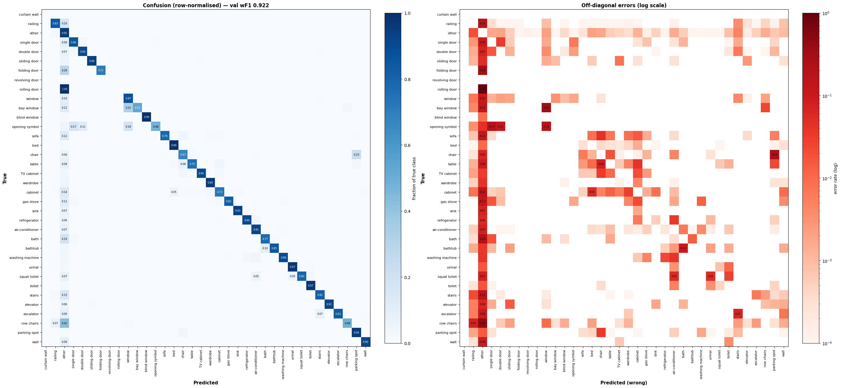
Figure 1. Confusion matrix (row-normalised) and off-diagonal errors (log scale), validation set.
Top 20 confusion pairs
true predicted count pct
-----------------------------------------------------------------
railing other 12,482 16.0%
other railing 8,320 1.9%
other stairs 2,175 0.5%
chair parking spot 1,712 23.3%
stairs other 1,699 15.2%
row chairs other 1,402 42.2%
single door other 1,105 9.5%
wall other 999 9.1%
other window 988 0.2%
air-conditioner other 980 7.3%
other bed 921 0.2%
window other 827 10.3%
other double door 804 0.2%
other chair 753 0.2%
other single door 751 0.2%
other air-conditioner 691 0.2%
double door other 640 6.5%
other row chairs 635 0.1%
parking spot chair 607 3.4%
cabinet other 573 13.9%

Per-class accuracy (sorted by hardest)
 | true_class | support | correct_pct | top_wrong | wrong_pct
0 | rolling door | 2 | 0.000000 | other | 100.000000
1 | opening symbol | 603 | 47.927032 | window | 18.407960
2 | row chairs | 3321 | 48.358928 | other | 42.216200
3 | bay window | 237 | 53.164557 | window | 32.067511
4 | chair | 7356 | 67.278412 | parking spot | 23.273518
5 | folding door | 41 | 70.731707 | other | 29.268293
6 | cabinet | 4109 | 72.426381 | other | 13.944999
7 | table | 3023 | 75.024810 | other | 8.699967
8 | bath | 3020 | 77.483444 | other | 18.973510
9 | sofa | 2771 | 78.599783 | other | 12.233851
10 | squat toilet | 1464 | 79.781421 | other | 7.035519
11 | stairs | 11186 | 81.602003 | other | 15.188629
12 | gas stove | 1125 | 82.133333 | other | 11.555556
13 | escalator | 1557 | 82.980090 | other | 8.991651
14 | railing | 77932 | 83.239234 | other | 16.016527
15 | bathtub | 1924 | 85.083160 | bath | 9.979210
16 | single door | 11677 | 85.672690 | other | 9.463047
17 | window | 8004 | 87.231384 | other | 10.332334
18 | washing machine | 1535 | 89.381107 | air-conditioner | 3.973941
19 | TV cabinet | 1561 | 90.006406 | chair | 3.203075
20 | refrigerator | 1912 | 90.062762 | other | 5.596234
21 | double door | 9838 | 90.119943 | other | 6.505387
22 | wall | 10920 | 90.402930 | other | 9.148352
23 | elevator | 3317 | 91.136569 | other | 6.029545
24 | air-conditioner | 13351 | 91.169201 | other | 7.340274
25 | sink | 1162 | 93.029260 | other | 6.798623
26 | sliding door | 3359 | 93.539744 | other | 4.912176
27 | parking spot | 17646 | 94.457667 | chair | 3.439873
28 | wardrobe | 8153 | 95.130627 | other | 4.305164
29 | other | 433889 | 95.430629 | railing | 1.917541
30 | urinal | 3826 | 96.915839 | other | 1.620491
31 | toilet | 8554 | 97.229366 | other | 1.741875
32 | bed | 24445 | 98.633667 | other | 1.014522
33 | blind window | 1782 | 99.158249 | other | 0.841751

Visualising: 0351-0025.svg
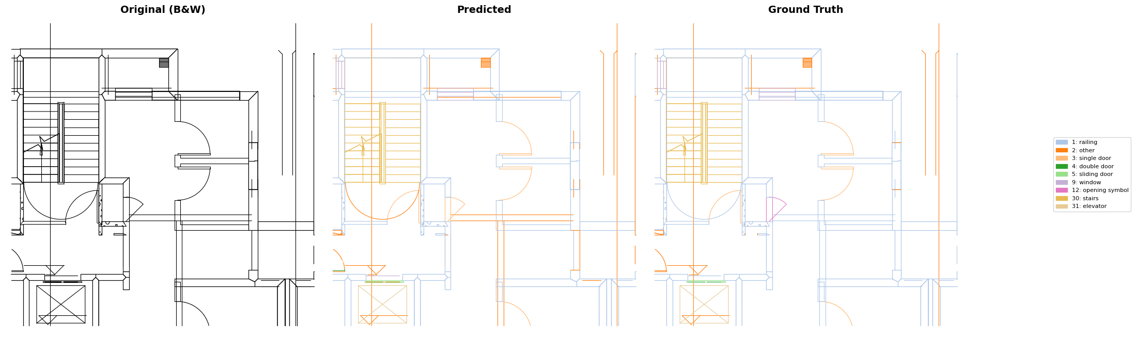
Figure 2. B&W vs predicted vs ground truth on drawing 0351-0025.svg.
drawing accuracy: 0.931 (689/740 paths)
Test set (5494 graphs)
wF1 0.9158 (paper 0.890)
mF1 0.7550 (paper 0.790)
Channel ablation (val set)
config wF1 mF1 Δ wF1
--------------------------------------------------------
full (knn+weld+delaunay) 0.9222 0.7992 +0.0000
no delaunay 0.8584 0.6589 -0.0638
no knn 0.7790 0.4137 -0.1432
no weld 0.7361 0.4115 -0.1860
knn only 0.6061 0.1372 -0.3161
weld only 0.6242 0.1355 -0.2980
delaunay only 0.5231 0.0615 -0.3990
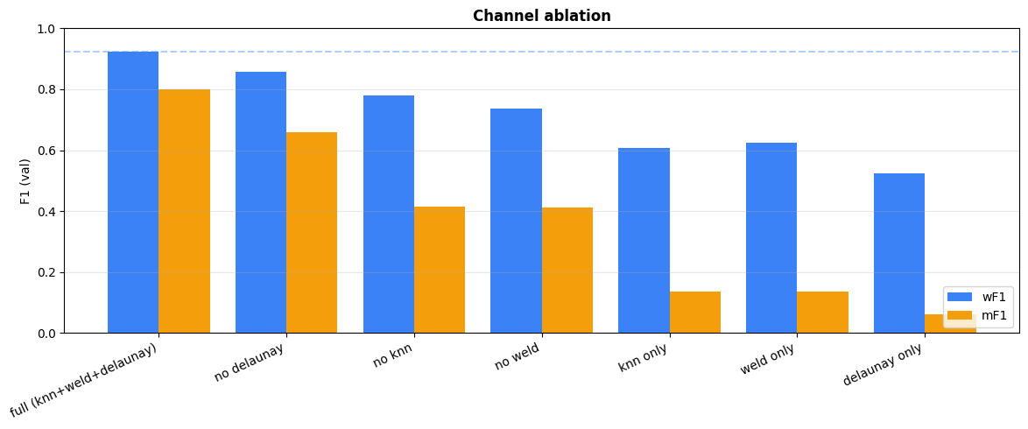
Figure 3. Channel ablation.
Feature importance (input-gradient saliency)
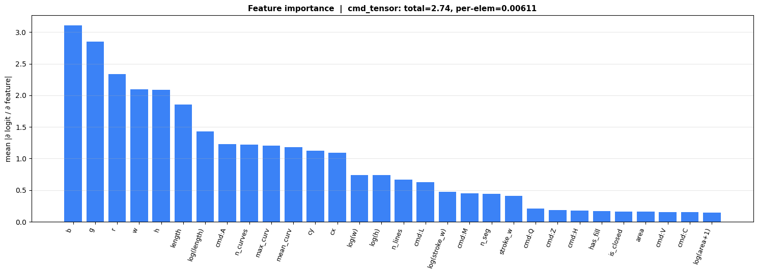
Figure 4. Feature importance (input-gradient saliency).
Top 10 most important geometric features:
1. b 3.108
2. g 2.851
3. r 2.338
4. w 2.092
5. h 2.085
6. length 1.851
7. log(length) 1.426
8. cmd:A 1.228
9. n_curves 1.221
10. max_curv 1.207

Bottom 5 (least important):
26. is_closed 0.1624
27. area 0.1584
28. cmd:V 0.1543
29. cmd:C 0.1513
30. log(area+1) 0.1489

Artifacts saved under /content/drive/MyDrive/VectorGraphNET:
confusion_counts_20260501_2013.csv
confusion_normalised_20260501_2013.csv
confusion_summary_20260501_2013.csv
confusion_heatmaps_20260501_2013.png
ablation_channels_20260501_2013.png
feature_importance_20260501_2013.png

5. Test Set Deep Dive
Code | 359 lines
# ============================================================
# 5. Test Set Deep Dive
# ============================================================
# Run this AFTER training completes. Produces:
# - Headline metrics (wF1, mF1, accuracy)
# - Per-class F1 bar chart
# - Confusion heatmap (test-specific)
# - B&W → Predicted → GT visualization on a test drawing
# - Per-class precision vs recall scatter
# - All artifacts saved to Drive

import pandas as pd
import matplotlib.pyplot as plt
import matplotlib.patches as mpatches
from matplotlib.collections import LineCollection
from matplotlib.colors import LogNorm
from sklearn.metrics import confusion_matrix, classification_report
from datetime import datetime

DRIVE_OUT = Path("/content/drive/MyDrive/VectorGraphNET")
ts = datetime.now().strftime("%Y%m%d_%H%M")

# ---- Load best checkpoint ----
CKPT_PATH = EXPERIMENT_CKPT
ckpt = torch.load(CKPT_PATH, map_location=DEVICE)
model.load_state_dict(ckpt["model"])
model.eval()
print(f"Checkpoint: epoch {ckpt.get('epoch','?')}, "
f"val wF1 {ckpt.get('val_wf1',0):.4f}, val mF1 {ckpt.get('val_mf1',0):.4f}")

# ==================================================================
# 5a. Test inference
# ==================================================================
test_loader = DataLoader(test_ds, batch_size=CFG.batch_size,
shuffle=False, num_workers=0)

all_preds, all_gts = [], []
all_probs = []
with torch.no_grad():
for batch in tqdm(test_loader, desc="test inference"):
batch = batch.to(DEVICE)
batch = maybe_zero_color(batch)
out = model(batch)
probs = F.softmax(out["fine"], dim=-1)
all_preds.append(out["fine"].argmax(-1).cpu().numpy())
all_probs.append(probs.max(-1).values.cpu().numpy())
all_gts.append(batch["path"].y_fine.cpu().numpy())

preds = np.concatenate(all_preds)
gts = np.concatenate(all_gts)
probs = np.concatenate(all_probs)

test_wf1 = f1_score(gts, preds, average="weighted", zero_division=0)
test_mf1 = f1_score(gts, preds, average="macro", zero_division=0)
test_acc = (preds == gts).mean()

class_names = [FLOORPLANCAD_NAMES[i] for i in range(N_FINE)]

# ==================================================================
# 5b. Headline banner
# ==================================================================
display(HTML(
f"<div style='padding:16px 20px;background:#0f172a;color:#e5e7eb;"
f"border-left:4px solid #10b981;font-family:monospace;font-size:15px;"
f"margin:12px 0;'>"
f"<b>TEST SET RESULTS</b> &nbsp; ({len(test_ds):,} graphs, "
f"{len(gts):,} paths)<br><br>"
f"<table style='color:#e5e7eb;font-size:14px;'>"
f"<tr><td>wF1</td><td>&nbsp;&nbsp;</td>"
f"<td><b>{test_wf1:.4f}</b></td><td>&nbsp;&nbsp;</td>"
f"<td style='color:#9ca3af'>paper: 0.890</td>"
f"<td>&nbsp;&nbsp;</td>"
f"<td style='color:{'#10b981' if test_wf1>=0.890 else '#ef4444'}'>"
f"{'✓ BEATS' if test_wf1>=0.890 else '✗ below'}</td></tr>"
f"<tr><td>mF1</td><td></td>"
f"<td><b>{test_mf1:.4f}</b></td><td></td>"
f"<td style='color:#9ca3af'>paper: 0.790</td>"
f"<td></td>"
f"<td style='color:{'#10b981' if test_mf1>=0.790 else '#ef4444'}'>"
f"{'✓ BEATS' if test_mf1>=0.790 else '✗ below'}</td></tr>"
f"<tr><td>acc</td><td></td><td><b>{test_acc:.4f}</b></td></tr>"
f"</table></div>"))

# ==================================================================
# 5c. Per-class F1 bar chart
# ==================================================================
report_dict = classification_report(
gts, preds, target_names=class_names,
labels=list(range(N_FINE)), output_dict=True, zero_division=0)

rows = []
for i, name in enumerate(class_names):
if name in report_dict:
r = report_dict[name]
rows.append({"class": name, "id": i, "support": int(r["support"]),
"precision": r["precision"], "recall": r["recall"],
"f1": r["f1-score"]})
df = pd.DataFrame(rows)
df_sorted = df.sort_values("f1", ascending=True)

fig, ax = plt.subplots(figsize=(16, 8))
y_pos = np.arange(len(df_sorted))
bars = ax.barh(y_pos, df_sorted["f1"].values, color="#3b82f6", height=0.7)

# Color bars by performance
for bar, f1_val in zip(bars, df_sorted["f1"].values):
if f1_val < 0.5:
bar.set_color("#ef4444") # red: weak
elif f1_val < 0.7:
bar.set_color("#f59e0b") # amber: moderate
else:
bar.set_color("#10b981") # green: strong

ax.set_yticks(y_pos)
ax.set_yticklabels([f"{r['class']} ({r['support']:,})" for _, r in df_sorted.iterrows()],
fontsize=9)
ax.set_xlabel("F1 Score", fontsize=12)
ax.set_title(f"Per-Class F1 on Test Set — wF1={test_wf1:.3f}, mF1={test_mf1:.3f}",
fontsize=13, fontweight="bold")
ax.axvline(test_wf1, color="#3b82f6", ls="--", alpha=0.5, label=f"wF1={test_wf1:.3f}")
ax.axvline(test_mf1, color="#f59e0b", ls="--", alpha=0.5, label=f"mF1={test_mf1:.3f}")
ax.set_xlim(0, 1.05)
ax.legend(loc="lower right")
ax.grid(axis="x", alpha=0.3)
plt.tight_layout()
f1_chart_path = DRIVE_OUT / f"test_perclass_f1_{ts}.png"
plt.savefig(f1_chart_path, dpi=150, bbox_inches="tight", facecolor="white")
plt.show()

# ==================================================================
# 5d. Precision vs Recall scatter
# ==================================================================
fig, ax = plt.subplots(figsize=(10, 10))
for _, r in df.iterrows():
if r["support"] < 10:
continue
size = np.clip(np.log(r["support"] + 1) * 15, 20, 200)
ax.scatter(r["recall"], r["precision"], s=size, alpha=0.7, color="#3b82f6")
ax.annotate(r["class"], (r["recall"], r["precision"]),
fontsize=7, ha="center", va="bottom",
textcoords="offset points", xytext=(0, 5))

ax.plot([0, 1], [0, 1], "k--", alpha=0.2, label="P = R")
ax.set_xlabel("Recall", fontsize=12)
ax.set_ylabel("Precision", fontsize=12)
ax.set_title("Precision vs Recall per Class (test set)\n"
"size ∝ log(support)", fontsize=12, fontweight="bold")
ax.set_xlim(-0.02, 1.05); ax.set_ylim(-0.02, 1.05)
ax.legend(); ax.grid(alpha=0.3)
ax.set_aspect("equal")
plt.tight_layout()
pr_chart_path = DRIVE_OUT / f"test_precision_recall_{ts}.png"
plt.savefig(pr_chart_path, dpi=150, bbox_inches="tight", facecolor="white")
plt.show()

# ==================================================================
# 5e. Confusion heatmap (test set)
# ==================================================================
cm = confusion_matrix(gts, preds, labels=list(range(N_FINE)))
row_sums = cm.sum(axis=1, keepdims=True); row_sums[row_sums == 0] = 1
cm_norm = cm / row_sums

fig, ax = plt.subplots(figsize=(16, 14))
im = ax.imshow(cm_norm, cmap="Blues", vmin=0, vmax=1, aspect="auto")
ax.set_xticks(range(N_FINE)); ax.set_yticks(range(N_FINE))
ax.set_xticklabels(class_names, rotation=90, fontsize=8)
ax.set_yticklabels(class_names, fontsize=8)
ax.set_xlabel("Predicted", fontsize=11, fontweight="bold")
ax.set_ylabel("True", fontsize=11, fontweight="bold")
ax.set_title(f"Test Confusion (row-normalised) — wF1={test_wf1:.3f}",
fontsize=12, fontweight="bold")
for i in range(N_FINE):
for j in range(N_FINE):
v = cm_norm[i, j]
if v >= 0.05:
ax.text(j, i, f"{v:.2f}", ha="center", va="center",
fontsize=6, color=("white" if v > 0.5 else "black"))
plt.colorbar(im, ax=ax, fraction=0.046, pad=0.04)
plt.tight_layout()
cm_chart_path = DRIVE_OUT / f"test_confusion_{ts}.png"
plt.savefig(cm_chart_path, dpi=150, bbox_inches="tight", facecolor="white")
plt.show()

# ==================================================================
# 5f. Top confusion pairs
# ==================================================================
print("\nTop 15 confusion pairs (test set)")
print(f"{'True':<22} {'Predicted':<22} {'Count':>8} {'%':>8}")
print("-" * 65)
np.fill_diagonal(cm, 0)
flat = np.argsort(cm.flatten())[::-1]
shown = 0
gt_counts = np.bincount(gts, minlength=N_FINE)
for idx in flat:
if shown >= 15: break
t, p = np.unravel_index(idx, cm.shape)
if cm[t, p] == 0: break
pct = 100 * cm[t, p] / max(gt_counts[t], 1)
print(f"{class_names[t]:<22} {class_names[p]:<22} {cm[t,p]:>8,} {pct:>7.1f}%")
shown += 1

# ==================================================================
# 5g. Visualize on a TEST drawing (not train)
# ==================================================================
def _sample_path_points(d_string, n_points=30):
try: path = svgpathtools.parse_path(d_string)
except: return None
if len(path) == 0: return None
pts = []
for t in np.linspace(0, 1, n_points):
try: p = path.point(t); pts.append((p.real, p.imag))
except: pass
return np.array(pts) if len(pts) >= 2 else None

def _build_colormap(n):
cmap1 = plt.colormaps.get_cmap("tab20")
colors = [cmap1(i) for i in range(20)]
if n > 20:
cmap2 = plt.colormaps.get_cmap("tab20b")
colors += [cmap2(i) for i in range(n - 20)]
return colors[:n]

def visualize_test(svg_path, model, device, figsize=(22, 8), linewidth=0.8):
raw = parse_svg_paths(svg_path)
kept_f, kept_ct, kept_y, kept_pts = [], [], [], []
for p in raw:
f = path_features(p)
if f is None: continue
pts = _sample_path_points(p["d"])
if pts is None: continue
kept_f.append(f); kept_ct.append(f["cmd_tensor"])
kept_y.append(p["semantic_id"]); kept_pts.append(pts)
n = len(kept_f)
if n < KNN_K + 1:
print(f" only {n} paths — skipping"); return

X = np.stack([f["feat"] for f in kept_f])
Y = np.array(kept_y, dtype=np.int64)
centers = np.array([f["center"] for f in kept_f], dtype=np.float32)
cmin = centers.min(axis=0); cmax = centers.max(axis=0)
span = float(max(cmax[0]-cmin[0], cmax[1]-cmin[1], 1e-6))
bbox_diag = float(np.linalg.norm(cmax - cmin))
cn = (centers - cmin) / span
X[:,0]=cn[:,0]; X[:,1]=cn[:,1]; X[:,2]/=span; X[:,3]/=span

# KNN
nn_m = NearestNeighbors(n_neighbors=min(KNN_K+1,n)).fit(cn)
_, idx = nn_m.kneighbors(cn)
src, dst = [], []
for i in range(n):
for j in idx[i,1:]: src.append(i); dst.append(int(j))
knn_ei = np.array([src,dst], dtype=np.int64)

# Weld
weld_ei = build_weld_edges(kept_f, eps_abs=bbox_diag*WELD_EPS_FRAC)

# Delaunay
hyper_ei, num_tri, tri_pair_counts = build_delaunay_triangles(kept_f)

# Edge features
knn_ef = _compute_edge_features(kept_f, knn_ei, bbox_diag, tri_pair_counts)
weld_ef = _compute_edge_features(kept_f, weld_ei, bbox_diag, tri_pair_counts)

g = HeteroData()
g["path"].x = torch.from_numpy(X).float()
g["path"].y = torch.from_numpy(Y).long()
g["path"].cmd_tensor = torch.from_numpy(np.stack(kept_ct)).float()
g["path","knn","path"].edge_index = torch.from_numpy(knn_ei).long()
g["path","knn","path"].edge_attr = torch.from_numpy(knn_ef).float()
g["path","weld","path"].edge_index = torch.from_numpy(weld_ei).long()
g["path","weld","path"].edge_attr = torch.from_numpy(weld_ef).float()
g["hedge"].x = torch.zeros(num_tri, 1)
if hyper_ei.shape[1] > 0:
g["path","in_triangle","hedge"].edge_index = torch.from_numpy(hyper_ei).long()
else:
g["path","in_triangle","hedge"].edge_index = torch.zeros((2,0), dtype=torch.long)

if ZERO_STROKE_COLOR:
g["path"].x[:, list(RGB_INDICES)] = 0.0

model.eval(); g = g.to(device)
with torch.no_grad():
out = model(g)
pred_local = out["fine"].argmax(-1).cpu().numpy()
gt_local = g["path"].y.cpu().numpy()

colors = _build_colormap(N_FINE)
pred_colors = [colors[int(p)] for p in pred_local]
gt_colors = [colors[int(y)] for y in gt_local]

all_pts = np.concatenate(kept_pts)
xmn,ymn = all_pts.min(axis=0); xmx,ymx = all_pts.max(axis=0)
margin = max(xmx-xmn, ymx-ymn) * 0.02

fig, axes = plt.subplots(1, 3, figsize=figsize)
def draw(ax, pts, cs, title):
lc = LineCollection(pts, colors=cs, linewidths=linewidth, capstyle="round")
ax.add_collection(lc)
ax.set_xlim(xmn-margin, xmx+margin); ax.set_ylim(ymx+margin, ymn-margin)
ax.set_aspect("equal"); ax.axis("off")
ax.set_title(title, fontsize=14, fontweight="bold")
draw(axes[0], kept_pts, ["black"]*len(kept_pts), "Original (B&W)")
draw(axes[1], kept_pts, pred_colors, "Predicted")
draw(axes[2], kept_pts, gt_colors, "Ground Truth")

present = sorted(set(pred_local.tolist()) | set(gt_local.tolist()))
handles = [mpatches.Patch(color=colors[c],
label=f"{c}: {FLOORPLANCAD_NAMES.get(c,'?')}") for c in present]
fig.legend(handles=handles, loc="center right", fontsize=8,
ncol=1, frameon=True, bbox_to_anchor=(1.0, 0.5))
plt.tight_layout(); plt.subplots_adjust(right=0.85)
out_png = DRIVE_OUT / f"test_segmentation_{ts}.png"
plt.savefig(out_png, dpi=150, bbox_inches="tight", facecolor="white")
plt.show()

correct = (pred_local == gt_local)
print(f"\n drawing accuracy: {correct.mean():.3f} ({correct.sum()}/{len(correct)})")
return out_png

# Pick a test drawing with variety
test_viz_svg = test_svg_files[0]
for svg in test_svg_files[:50]:
paths = parse_svg_paths(svg)
n_cls = len(set(p["semantic_id"] for p in paths))
if n_cls >= 5 and len(paths) > 100:
test_viz_svg = svg; break

print(f"\nVisualising TEST drawing: {test_viz_svg.name}")
seg_path = visualize_test(test_viz_svg, model, DEVICE)

# ==================================================================
# 5h. Summary table
# ==================================================================
print("\n" + "=" * 65)
print("FULL PER-CLASS REPORT (test set)")
print("=" * 65)
print(classification_report(
gts, preds, target_names=class_names,
labels=list(range(N_FINE)), digits=3, zero_division=0))

# Save CSV
df.to_csv(DRIVE_OUT / f"test_perclass_{ts}.csv", index=False)

print(f"\nAll test artifacts saved to {DRIVE_OUT}:")
for name in [f"test_perclass_f1_{ts}.png",
f"test_precision_recall_{ts}.png",
f"test_confusion_{ts}.png",
f"test_segmentation_{ts}.png",
f"test_perclass_{ts}.csv"]:
print(f" {name}")
Output
Checkpoint: epoch 67, val wF1 0.9222, val mF1 0.7992
TEST SET RESULTS (5,494 graphs, 3,424,338 paths)

wF1 0.9158 paper: 0.890 ✓ BEATS
mF1 0.7550 paper: 0.790 ✗ below
acc 0.9156
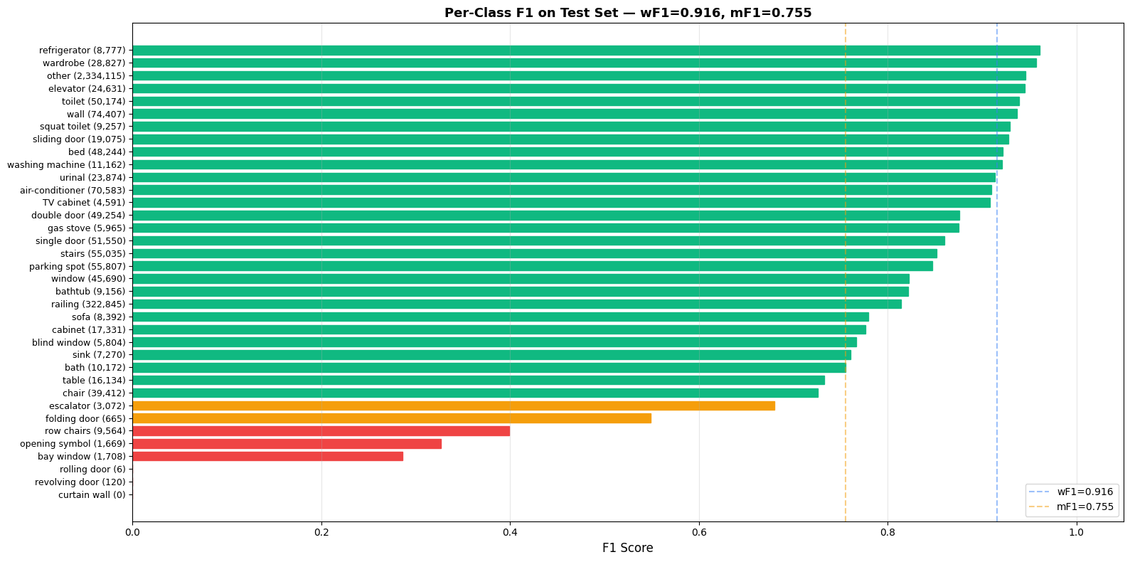
Figure 5. Per-class F1 on the test set.
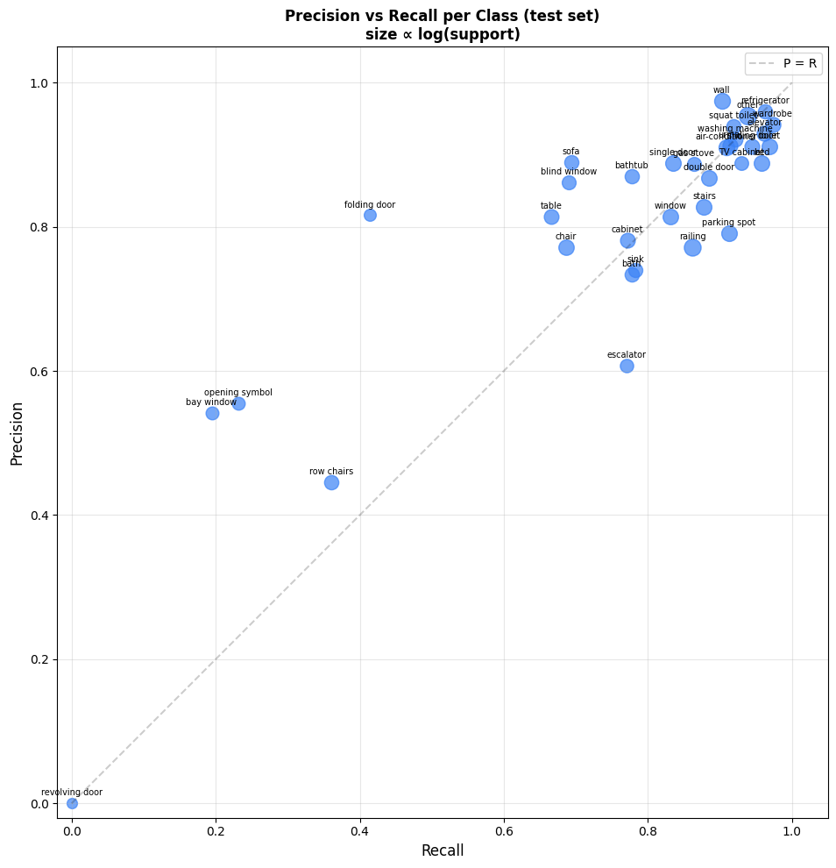
Figure 6. Precision vs recall per class (test set).
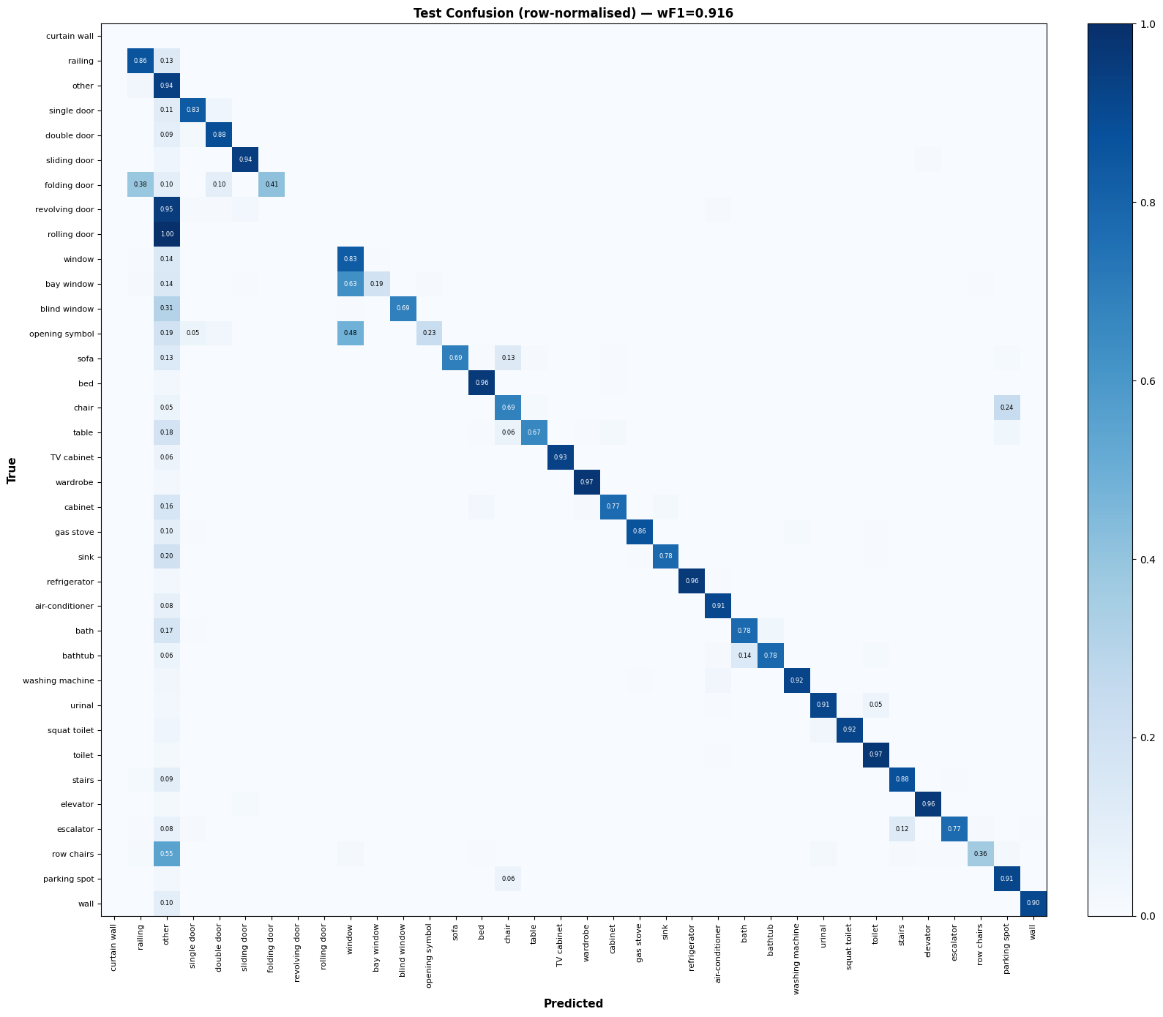
Figure 7. Test confusion matrix (row-normalised).
Top 15 confusion pairs (test set)
True Predicted Count %
-----------------------------------------------------------------
other railing 80,048 3.4%
railing other 42,555 13.2%
chair parking spot 9,333 23.7%
other stairs 8,418 0.4%
wall other 7,107 9.6%
window other 6,396 14.0%
other window 6,036 0.3%
single door other 5,827 11.3%
air-conditioner other 5,660 8.0%
row chairs other 5,267 55.1%
stairs other 5,225 9.5%
other air-conditioner 5,186 0.2%
other bed 4,934 0.2%
double door other 4,249 8.6%
other double door 4,214 0.2%

Visualising TEST drawing: 0001-0023.svg
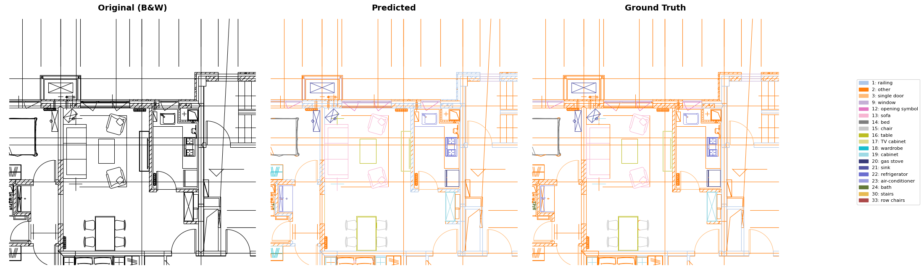
Figure 8. B&W vs predicted vs ground truth on test drawing 0001-0023.svg.
drawing accuracy: 0.871 (3987/4575)

=================================================================
FULL PER-CLASS REPORT (test set)
=================================================================
precision recall f1-score support

curtain wall 0.000 0.000 0.000 0
railing 0.772 0.862 0.814 322845
other 0.954 0.938 0.946 2334115
single door 0.888 0.835 0.860 51550
double door 0.868 0.885 0.876 49254
sliding door 0.912 0.945 0.928 19075
folding door 0.816 0.414 0.549 665
revolving door 0.000 0.000 0.000 120
rolling door 0.000 0.000 0.000 6
window 0.814 0.831 0.823 45690
bay window 0.542 0.194 0.286 1708
blind window 0.862 0.691 0.767 5804
opening symbol 0.555 0.231 0.327 1669
sofa 0.889 0.694 0.779 8392
bed 0.889 0.958 0.922 48244
chair 0.771 0.686 0.726 39412
table 0.814 0.666 0.733 16134
TV cabinet 0.888 0.930 0.908 4591
wardrobe 0.942 0.973 0.957 28827
cabinet 0.781 0.771 0.776 17331
gas stove 0.887 0.864 0.875 5965
sink 0.740 0.783 0.761 7270
refrigerator 0.960 0.962 0.961 8777
air-conditioner 0.910 0.909 0.910 70583
bath 0.734 0.777 0.755 10172
bathtub 0.871 0.777 0.821 9156
washing machine 0.921 0.921 0.921 11162
urinal 0.913 0.914 0.914 23874
squat toilet 0.940 0.919 0.929 9257
toilet 0.911 0.969 0.939 50174
stairs 0.827 0.878 0.852 55035
elevator 0.929 0.962 0.945 24631
escalator 0.608 0.771 0.680 3072
row chairs 0.446 0.361 0.399 9564
parking spot 0.792 0.912 0.848 55807
wall 0.974 0.903 0.937 74407

accuracy 0.916 3424338
macro avg 0.759 0.725 0.734 3424338
weighted avg 0.917 0.916 0.916 3424338

All test artifacts saved to /content/drive/MyDrive/VectorGraphNET:
test_perclass_f1_20260501_2014.png
test_precision_recall_20260501_2014.png
test_confusion_20260501_2014.png
test_segmentation_20260501_2014.png
test_perclass_20260501_2014.csv

